Name:
Date:
School:
Facilitator:

7.01 Types of Polygons Study Guide
Match the terms to their definitions.
1. Polygon a. Line that connect two non-adjacent vertices
2. Convex b. The intersection point of two sides
3. Vertex c. A polygon where all diagonals are contained inside the figure
4. Diagonal d. A polygon where at least one diagonal is found outside the figure
5. Concave e. A closed figure made up of a finite number of sides
6. Side f. When all angles of a figure are equal measures
7. Equilateral g. A line used to create a shape
8. Equiangular h. When all lines of a figure are equal lengths
9. Regular I. A polygon which has all sides equal and all angle measures equal
Write in the number of sides for each polygon mentioned below

10. Triangle
11. Pentagon
12. Heptagon
13. Hexagon `
14. Decagon
15. Quadrilateral
16. Octogon
17. Nonagon
18. Dodecogon
19. 23-gon

A nine-sided figure.
- The side measures are 11 units, 11 units, 11 units, 11 units, 11 units, 11 units, 11 units, 11 units, and 11 units.
- The eight angle measures given are 160 degrees, 160 degrees, 160 degrees, 160 degrees, 60 degrees, 225 degrees, 225 degrees, and 60 degrees.
- The ninth angle measure is not given.
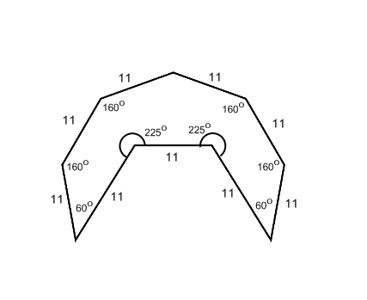
20. Identify the polygon below. Classify it as convex or concave. State if it is equilateral, equiangular, regular or neither.
Number of sides:
Concave or convex:
Equilateral, equiangular, regular, or neither:

