Name:

Date:

School:

Facilitator:

6.07 Congruent Triangles – SSS and SAS Study Guide

**Match the terms to their definitions.**

      1. Corresponding a. Exactly the same including size and shape

      2. SAS b. Positioned in a similar fashion and location

      3. SSS c. Side-Side-Side congruency postulate

      4. Congruent d. Side-Angle-Side congruency postulate

      5. AAS e. Angle-Side-Angle congruency postulate

      6. ASA f. Angle-Angle-Side congruency postulate

**Drag the symbols to mark the triangles below.**

7. Mark the triangles such that 8. Mark the triangles such that

∠A ≅ ∠R ; $\overline{AB}$ ≅ $\overline{RT}$; ∠B ≅ ∠T ≅ ; ≅ ; ≅

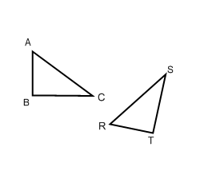What congruency type is this?       What congruency type is this?

9. Mark the triangles such that 10. Mark the triangles such that

∠A ≅ ∠R ; $\overline{BC }$ ≅ $\overline{TS}$; ∠C ≅S ∠A ≅ ∠R ; $\overline{AC}$ ≅ $\overline{RS}$; $\overline{AB}$ ≅ $\overline{RT}$

What congruency type is this?       What congruency type is this?

11. What if we can find that all three angles have a corresponding congruent match? (AAA)

Does this prove congruency? Explain your reasoning.