Name:

Date:

School:

Facilitator:

6.04 Transformations

# Total Points: 24

**Identify the transformation.**

**1.**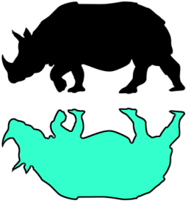

**2.** 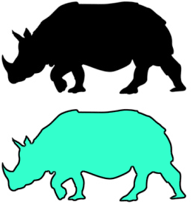

**3.** 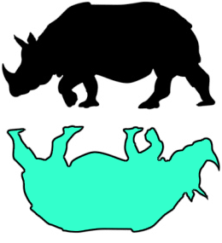

**4.** Look at the three images below. For each image describe a transformations used to create the image. Be sure to describe a different transformation for each figure.

A.

B. 

C. 