Name:
Date:
School:
Facilitator:

6.03 Triangle Perimeter and Area

Total Points: 42
1. Use the triangle in the coordinate plane to find its perimeter.
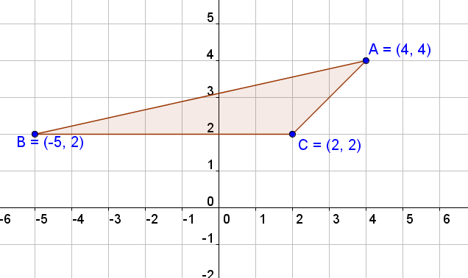

BC
d =
Show your work below:

AB
d =
Show your work below:

AC
d =
Show your work below:

Perimeter
P = BC + AB + AC
P = + +
P =

2. Use the triangle in the coordinate plane to find its perimeter.
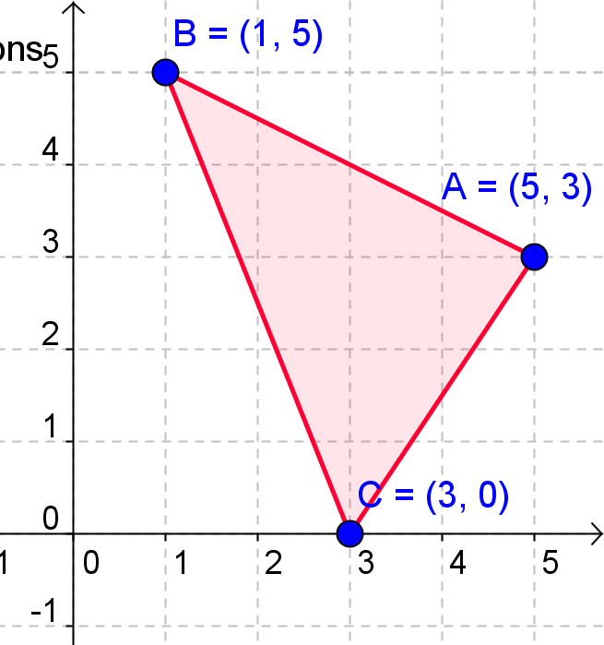

BC
d =
Show your work below:

AB
d =
Show your work below:

AC
d =
Show your work below:

Perimeter
P = BC + AB + AC
P = + +
P =

3. Use the triangle in the coordinate plane to find its perimeter.

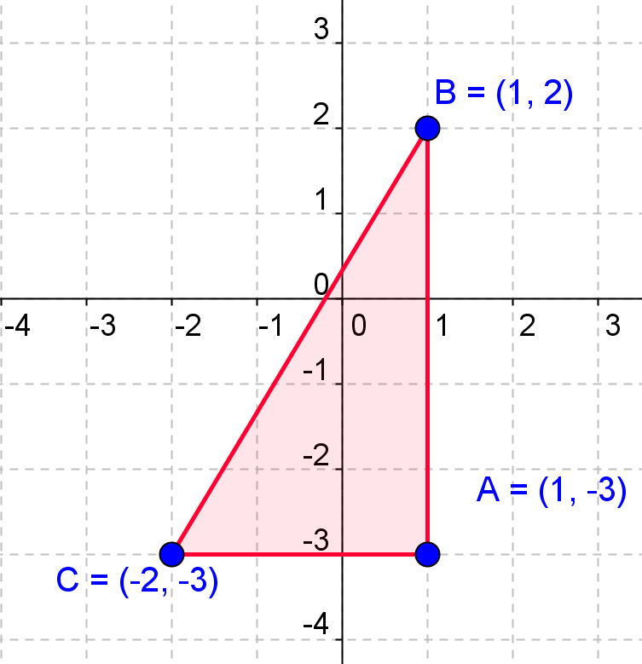

BC
d =
Show your work below:

AB
d =
Show your work below:

AC
d =
Show your work below:
Perimeter
P = BC + AB + AC
P = + +
P =

4. Use the triangle in the coordinate plane to find its area.
Use $A=\frac{1}{2}bh.$

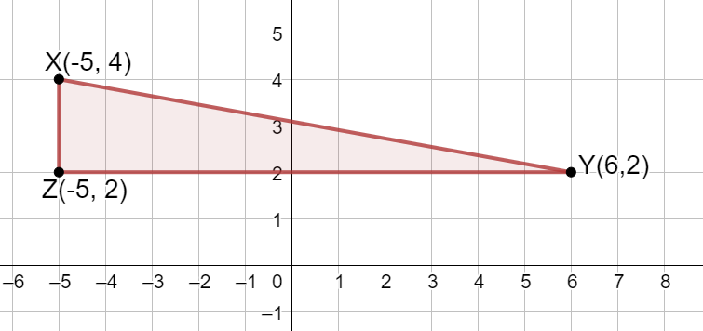

ZY =
Show your work below:

XZ =
Show your work below:
Area =
Show your work below:

5. Use the triangle in the coordinate plane to find its area.
Use $A=\frac{1}{2}bh$

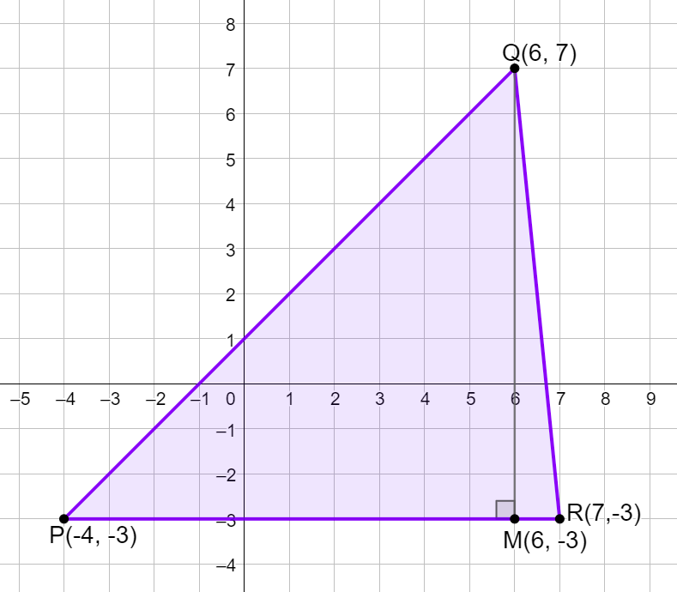
PR =
Show your work below:

QM =
Show your work below:
Area =
Show your work below:

