Name:
Date:
School:
Facilitator:

6.01 Triangles and Angles

Total Points: 40
Classify each triangle by its sides and angles.
Sides: scalene, isosceles, equilateral
Angles: acute, obtuse, right, equiangular

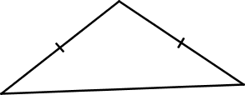
1. Sides Angles

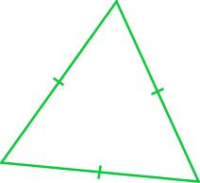
2. Sides Angles

3. Sides Angles

4. Sides Angles

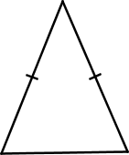
5. Sides Angles

Find x and classify each triangle by its angles. Provide the theorem (sum of interior angles or exterior angle theorem) you used to solve the problem.
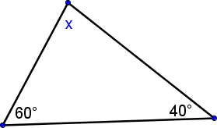

6. x =
Show your work below:

Classification by angles Theorem

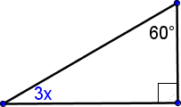

7. x =
Show your work below:

Classification by angles Theorem

8. x =
Show your work below:
Classification by angles Theorem

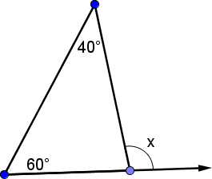

9. x =
Show your work below:

Classification by angles Theorem

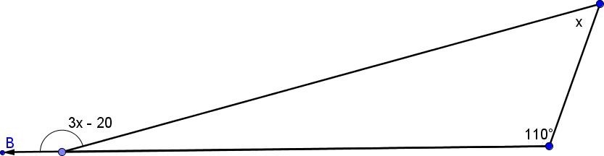
10. x =
Show your work below:

Classification by angles Theorem

