Name:
Date:
School:
Facilitator:

6.04 Triangles and Angles Additional Practice Key
Here are some additional practice problems to help you. You will not turn these in. They are just to help you better understand.

A.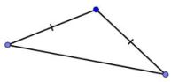 B. C. 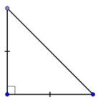 D. 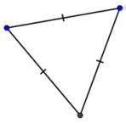

1. From the four images above, select the isosceles obtuse triangle. Answer: A

2. From the four images above, select the scalene right triangle. Answer: B

3. Classify triangle RST in relation to its sides.
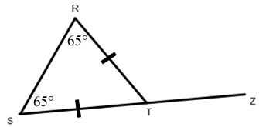
- Equilateral
- Scalene
- Isosceles
- Two sided
Answer: c. Isosceles

4. Consider triangle AFE and identify an exterior angle from the choices.
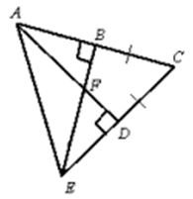
- Angle EBC
- Angle ABE
- Angle BFA
- Angle AFE
Answer: c. Angle BFA

- 5. One acute angle in a right triangle has a measure of 34.6°. What is the measure of the other acute angle?
- 145.4°
- 34.6°
- 55.4°
- 90°
Answer: b. 55.4°

6. A(n) exterior angle is formed when a side of a triangle has been extended.

7. A(n) scalene triangle has no congruent side lengths.

8. Non-adjacent interior angles to the exterior angle of a triangle form remote interior angles.

9. A triangle with three acute angles is a(n) acute triangle.

10. A triangle with three congruent side lengths is a(n) equilateral triangle.

11. A triangle with one obtuse angle is a(n) obtuse triangle.

12. A triangle with at least two congruent side lengths is a(n) isosceles triangle.

13. A triangle with one right angle is a(n) right triangle.

14. The triangle sum theorem states that the sum of all three angles is a triangle is 180°.

15. The exterior angle theorem states that the measure of an exterior angle is a triangle is equal to the sum measures of the two non-adjacent interior angles.

