Name:
Date:
School:
Facilitator:

5.04 Proving Lines Parallel
Total Points: 56
Are lines x and y parallel? State your reasoning for each answer.
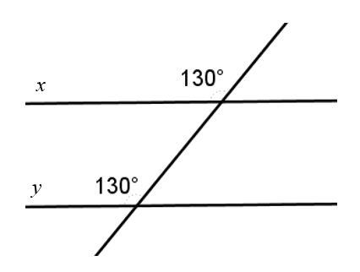 | 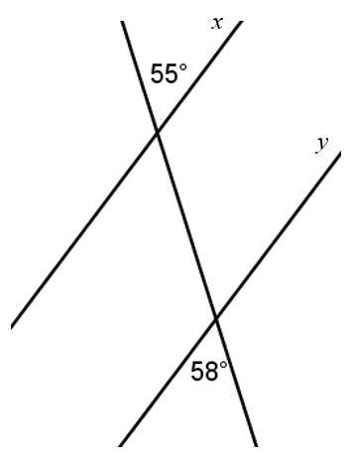
- Are lines x and y parallel? (yes / no) :  Reason: | - Are lines x and y parallel? (yes / no) :  Reason:
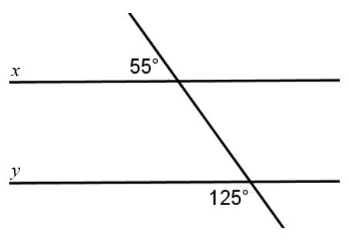 | 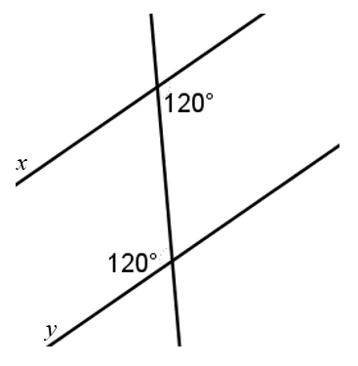
y
- Are lines x and y parallel? (yes / no) :  Reason: | - Are lines x and y parallel? (yes / no) :  Reason:
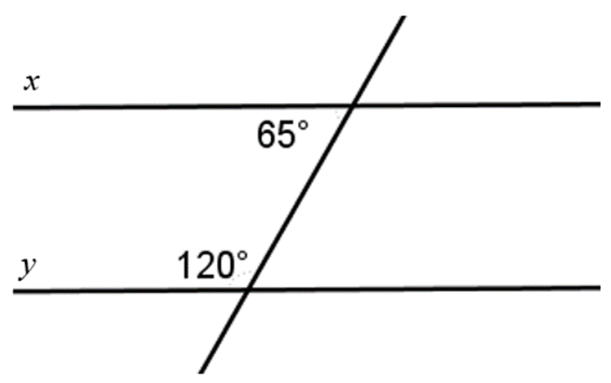 | 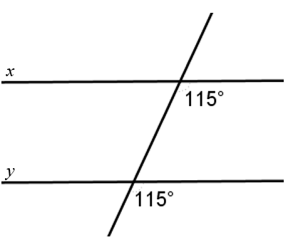
- Are lines x and y parallel? (yes / no) :  Reason: | - Are lines x and y parallel? (yes / no) :  Reason:

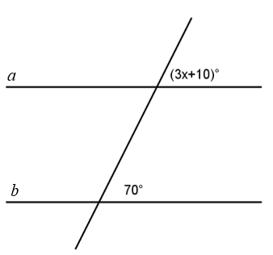
7. For lines a and b to be parallel, what is the value of x?:
Work:

