Name:
Date:
School:
Facilitator:

5.03 Transversals and Parallel Lines
Total Points: 58

Use diagram below for problems 1-6:
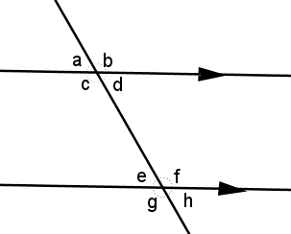
Describe the relationship of the pair of angles as
- alternate interior
- alternate exterior
- corresponding
- same side interior
- same side exterior.

Then, state whether the angles are congruent or supplementary.
- a and e:
Congruent or supplementary?
- d and e:
Congruent or supplementary?
- b and h:
Congruent or supplementary?
- c and e:
Congruent or supplementary?
- d and h:
Congruent or supplementary?
- b and g:
Congruent or supplementary?

Find x for problems 7-11 below. Show your work for full credit.

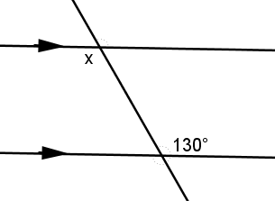 | 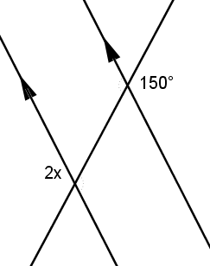
7) x = º | 8) x = º
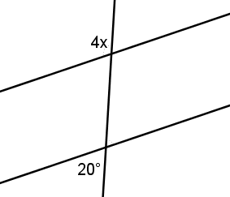 | 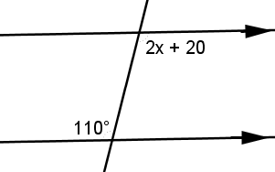
9) x = º | 10) x = º
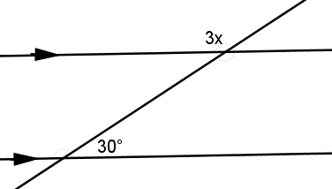
11) x = º

Use diagram below to answer problems 12-18. Give your reasoning to each answer:
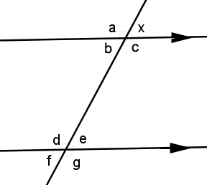
m∠x = 70º.

12) Find m∠a: º; reason:
13) Find m∠b: º; reason:
14) Find m∠c: º; reason:
15) Find m∠d: º; reason:
16) Find m∠e: º; reason:
17) Find m∠f: º; reason:
18) Find m∠g: º; reason:

19) Match the reasons with the statement for the following proof.
Choices:
A. Transitive property of
congruent angles
B. Given
C. Vertical angles are
congruent
D. Given
1.
2.
3. Corresponding angles are congruent
4.
5.

