Name:
Date:
School:
Facilitator:

5.03 Parallel Lines Additional Practice Key
Here are some additional practice problems to help you. You will not turn these in. They are just to help you better understand.

Questions 1 and 2 refer to this image.
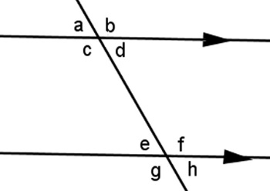
1. Which angle forms an alternate interior angle pair with c?
Answer: f
Angles c and f form an alternate interior angle pair because they are inside the parallel lines, and on opposite sides of the transversal. Angles d and e form the other alternate interior angle pair in this diagram.

2. Which angle forms a same side exterior angle pair with angle h?
Answer: b
Angles b and h form a same side exterior angle pair because they are outside the parallel lines, and on the same side of the transversal. Angles a and g form the other same side exterior angle pair in this diagram.

Questions 3 – 5 refer to this image.
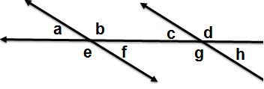

3. Use the diagram to identify the pair angles: f and g
Answer: same side interior

4. Use the diagram to identify the pair angles: a and c
Answer: corresponding

5. Use the diagram to identify the pair angles: a and h
Answer: alternate exterior

6. Angle pairs created where a transversal crosses two (usually parallel) lines. Each pair of these angles are outside the parallel lines, and on the same side of the transversal.
Answer: same side exterior

