Name:
Date:
School:
Facilitator:

5.03 Parallel Lines Additional Practice
Here are some additional practice problems to help you. You will not turn these in. They are just to help you better understand.

Questions 1 and 2 refer to this image.
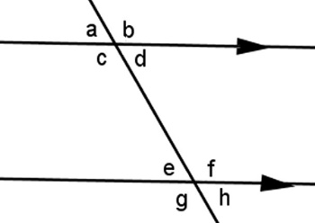
1. Which angle forms an alternate interior angle pair with c?

2. Which angle forms a same side exterior angle pair with angle h?

Questions 3 – 5 refer to this image.
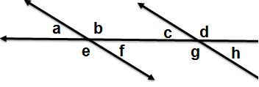

3. Use the diagram to identify the pair angles: f and g

4. Use the diagram to identify the pair angles: a and c

5. Use the diagram to identify the pair angles: a and h

6. Angle pairs created where a transversal crosses two (usually parallel) lines. Each pair of these angles are outside the parallel lines, and on the same side of the transversal.

