Name:
Date:
School:
Facilitator:

4.02 Perpendicular Lines
Total Points: 69

For problems 1-5, lines m and n are perpendicular to each other. Solve for x. Show your work.
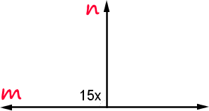 | 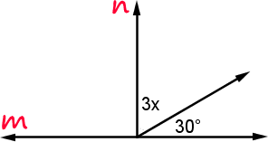

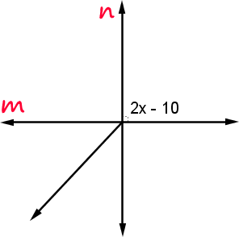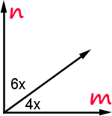
- 4.

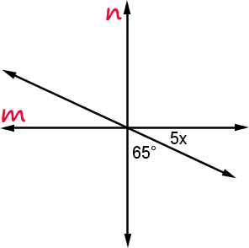
5.

6. Describe the difference between parallel and perpendicular lines.

7. What is the definition of a perpendicular bisector?

8. Construct a perpendicular bisector with a compass and a straight edge. Use the instructions in example #9 of the lesson.
Use paper, a straightedge and a compass. Place a scan or picture of your hand-drawn construction as well.

9. Construct a perpendicular bisector using GeoGebra. Use the same directions in the Construct a Perpendicular Bisector activity that is on the task page. Take a screen shot (Print Screen) and paste here.

a. What are the lengths of segments AE and EB?
AE:
EB:

b. What is the length of segment AB?

c. What figure is the perpendicular bisector in your construction?

10. Which construction was easier to make? Explain why. When might you have to use these constructions?

