Name:
Date:
School:
Facilitator:

5.02 Perpendicular Lines Study Guide
Skew Lines Perpendicular Bisector
Adjacent Angles Linear Pair
Parallel Lines Vertical Angles
Perpendicular Lines
Fill in the blanks with the word that corresponds to the correct definition or diagram.
- A line, ray, or segment that passes through the midpoint and is perpendicular to that segment.
- Lines that do not intersect and do not lie in the same plane.
- Lines that intersect to form right angles.
- Coplanar lines that do not intersect.
- A pair of adjacent angles whose non-common sides form opposite rays (lines).
- Angles that share a common side, common vertex, and have no common interior points.
- Two non-adjacent angles that are formed by intersecting lines and are always congruent.

Match each theorem with the diagram that best represents it.
- b. c.
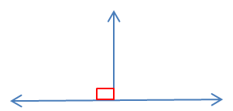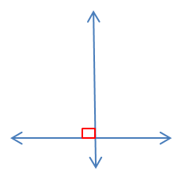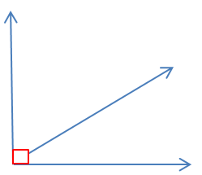

- Perpendicular lines intersect to form congruent adjacent angles

- If the non-common sides of two adjacent angles form a right angle, then the angles are complementary.

- Perpendicular lines intersect to form four right angles.

Give a real world example of each geometric concept.

- Parallel Planes –

- Perpendicular Lines –

