Name:

Date:

School:

Facilitator:

4.07 Proving Angle Relationships

Total Points: 48

**Match each statement with the definition, property, postulate, or theorem that justifies it.**

|  |  |  |
| --- | --- | --- |
| **A.** Definition of Complementary | **B.** Substitution Property | **C.** Definition of Right Angle |
| **D.** Transitive property | **E.** Supplement Theorem | **F.** Congruent Right Angles Theorem |

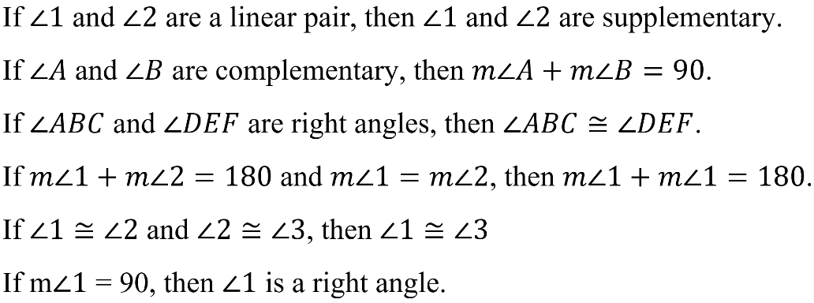

|  |  |  |
| --- | --- | --- |
| 1. |  |  |
| 2. |  |  |
| 3. |  |  |
| 4. |  |  |
| 5. |  |  |
| 6. |  |  |

**Complete each proof below.**

|  |  |  |  |  |
| --- | --- | --- | --- | --- |
|  | |  | | |
|  | |
|  | **Statements** | | **Reasons** |  |
|  |  | | a. |  |
|  |  | |  |  |
|  |  | | b. |  |
|  |  | |  |  |
|  |  | | c. |  |
|  |  | |  |  |
|  |  | | d. |  |
|  |  | |  |  |
|  |  | | e. |  |
|  |  | |  |  |
|  |  | | f. |  |

|  |  |  |  |
| --- | --- | --- | --- |
|  |  | | |
|  |
| **Statements** | **Reasons** |  |
|  | a. |  |
|  |  |  |
|  | b. |  |
|  |  |  |
|  | c. |  |