Name:
Date:
School:
Facilitator:

3.07 Equations of Perpendicular Lines
Total Points: 45

Give the slope of each line. Also, state if the lines are perpendicular (yes or no).

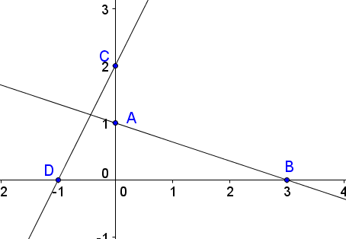
1. Slope of line AB:
Slope of line CD:
Are the lines perpendicular (yes or no):

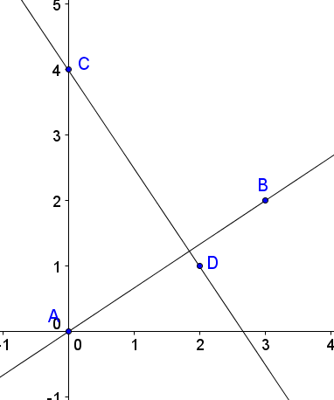
2. Slope of line AB:
Slope of line CD:
Are the lines perpendicular (yes or no):

3. Give the slope of each line. Also, state if the lines are perpendicular (yes or no).
$y= \frac{1}{2}x+4$ AB: and CD: $y=- \frac{1}{2}x-2$
Slope of line AB:
Slope of line CD:

Are the lines perpendicular (yes or no):

4. Give the slope of each line. Also, state if the lines are perpendicular (yes or no).
AB: $y=- \frac{1}{3}x+4$ and CD: y = 3x -2
Slope of line AB:
Slope of line CD:
Are the lines perpendicular (yes or no):
5. Give the slope of each line. Also, state if the lines are perpendicular (yes or no).
AB: y + 4x = 1 and CD: $y= \frac{1}{4}x-2$
Slope of line AB:
Slope of line CD:
Are the lines perpendicular (yes or no):

6. Give the slope of each line. Also, state if the lines are perpendicular (yes or no).
AB: 2y + 2x = 8 and CD: y – 1x = 2

Slope of line AB:
Slope of line CD:
Are the lines perpendicular (yes or no):
7. Find the equation of a line in slope intercept form that is perpendicular to the line
$y= \frac{1}{3}x-5$ that goes through the point (6, 4).
Solution:

8. Find the equation of a line in slope intercept form that is perpendicular to the line y = -2x - 3 that goes through the point (2, 1).
Solution:
9. What must be true about the slope of a line that is perpendicular to the line with equation?
A) same
B) opposite
C) reciprocal
D) both B & C
10. If the lines are perpendicular, who wrote the correct equations, Robert or Justin? Why?
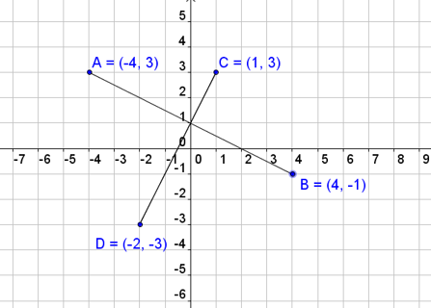
Robert:
$\overset{⃡}{AB}$
$$y = - \frac{1}{2} x+ 1 \\ \overset{⃡}{CD}$$
$$y = 2 x+ 1$$

Justin:
$$\overset{⃡}{AB}$$
$$y = - \frac{1}{2} x+ 1 \\ \overset{⃡}{CD}$$
$$y = -2 x+ 1$$

