Name:

Date:

School:

Facilitator:

3.06 Equations of Parallel Lines

Total Points: 48

1. Give the slope of each line. Also, state if the lines are parallel (yes or no).

line AB and line CD on a coordinate plane; point A has coordinates (zero, one); point B has coordinates (one, zero); point C has coordinates (negative four, zero); point D has coordinates (zero, negative five) 


Slope of line AB:

Slope of line CD:

Are the lines parallel (yes or no):

2. Give the slope of each line. Also, state if the lines are parallel (yes or no).

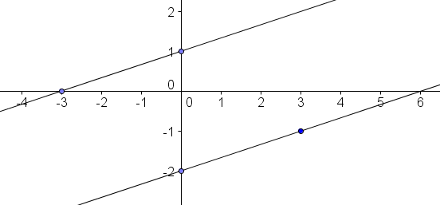

Slope of line AB:

Slope of line CD:

Are the lines parallel (yes or no):

3. Give the slope of each line. Also, state if the lines are parallel (yes or no).

Slope of line AB:

Slope of line CD:

Are the lines parallel (yes or no):

4. Give the slope of each line. Also, state if the lines are parallel (yes or no).

AB: y = - 3x + 4 and CD: y = - 3x -2

Slope of line AB:

Slope of line CD:

Are the lines parallel (yes or no):

5. Give the slope of each line. Also, state if the lines are parallel (yes or no).  
Hint: rewrite to slope intercept form.

AB: y + 4x = 1 and CD: y = - 4x -2

Slope of line AB:

Slope of line CD:

Are the lines parallel (yes or no):

6. Give the slope of each line. Also, state if the lines are parallel (yes or no).  
Hint: rewrite to slope intercept form.

AB: 2y + 2x = 8 and CD: y + x = 2  
  
 Slope of line AB:        
 Slope of line CD:

Are the lines parallel (yes or no):

7. Find the equation of a line in slope intercept form that is parallel to the line below that goes through the point (6, 4).

$y= \frac{1}{3}x-5$

Work:        
 Answer:

8. Find the equation of a line in slope intercept form that is parallel to the line y = -2x - 3 that goes through the point (2, 1).

Work:        
 Answer:

9. Krista and Emily wrote an equation of a line that is parallel to the line y = 3x - 1 and passing through the point (5,9). Is either of them correct? Explain your reasoning?

Krista:

9 = 3(5) + *b*

9 = 15 + *b*

-6 = *b*

*y* = 3*x* - 6

Emily:

*y* – 9 = 3(*x* – 5)

*y* – 9 = 3*x* – 15

*y* = 3*x* – 24

Answer:         
Explanation:

10. Jack and Jill were working on their homework together but ended up with two different answers to the same problem. The problem asked for a new line, parallel to y=2x+3, and containing the point (-2,-2). Who got the problem correct? Explain your reasoning?

Jack:

*y* – 2 = 2(*x* – 2)

*y* – 2 = 2*x* – 4

*y* = 2*x* - 2

Jill:

*y* + 2 = 2(*x* + 2)

*y* + 2 = 2*x* + 4

*y* = 2*x* + 2

Answer:         
Explanation: