Name:

Date:

School:

Facilitator:

3.01 Graphing Linear Equations Using a Table of Values

Total Points: 23

This task requires you to create a graph. You have several options:

* Draw the graph by hand, then photograph or scan your graph;
* Use the Microsoft Word or Google Docs drawing tools to graph your data; or
* Use the GeoGebra linked on the Task page of the lesson to create the graph; then, insert a screenshot of the graph into this task.

**Make a table of values for each equation with at least 3 domain values. Then, graph the equation using the points from the table of values.**

1. *y* = −3*x* + 1

| ***X*** | ***Y*** |
| --- | --- |
|  |  |
|  |  |
|  |  |

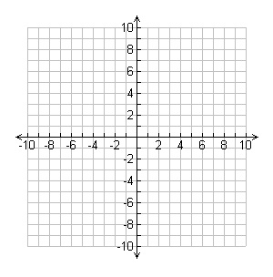

2. *y* = *x* + 4

| ***X*** | ***Y*** |
| --- | --- |
|  |  |
|  |  |
|  |  |



3. *y* = 4*x*

| ***X*** | ***Y*** |
| --- | --- |
|  |  |
|  |  |
|  |  |



**For problems 4 and 5, match the equation to the correct graph. List the letter of the graph that matches.**

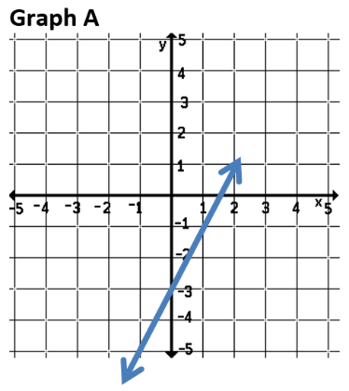 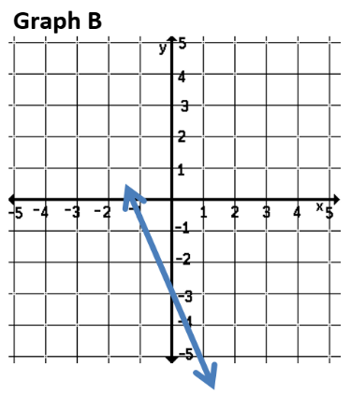 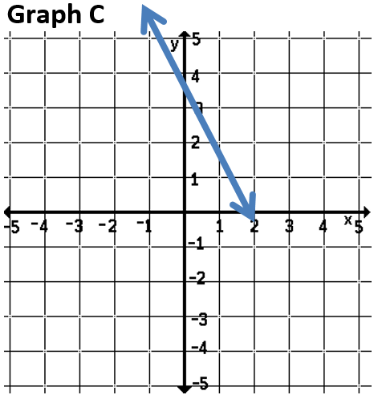

4. *y* = −2*x* + 3

5. *y* = 2*x* – 3

**Answer the following questions using the scenario below. Write your answers as an ordered pair, (hours, $).** **Show your work for full credit.**

Suppose you hire an electrician to install several electrical outlets in your home. The electrician charges $68.00 for materials plus $40.00 per hour for labor.

6. How much will the electrician charge you if the job take 2 hours?

7. How much will the electrician charge you if the job take 5 hours?