Name:

Date:

School:

Facilitator:

2.06 Angle Pair Relationships

# Total Points: 32

**Use this figure for questions 1-4:**

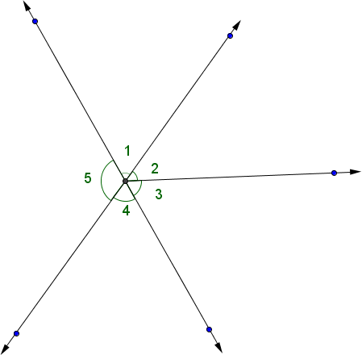

1. Are angles 1 and 2 a linear pair?
2. Are angles 4 and 5 a linear pair?
3. Are angles 1 and 4 vertical angles?
4. Are angles 3 and 5 vertical angles?

**Use this figure for questions 5 and 6:**

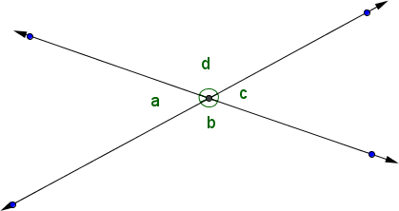

1. If m∠a = 35o, then m∠b =      o
2. If m∠b = 130o, then m∠d =      o
3. **Given** m∠r and m∠s are supplementary, then if m∠r= 120o, then m∠s =      o
4. Given m∠r and m∠s are complementary, then if m∠r= 40o, then m∠s =      o

**Find the values of the variables:**

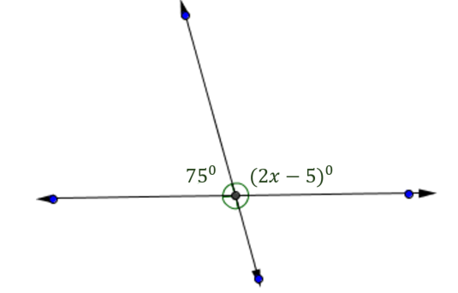

1. ***x* =**

**
two lines intersecting at a point, the measures of the four angles formed are given as 156 degrees, 3x-48 degrees, y degrees , and x degrees 
**

1. ***x* =**

***y* =**