Name:

Date:

School:

Facilitator:

2.06 Angles and Their Measures Study Guide

Acute Angle Degree Straight Angle

Angle Obtuse Angle Vertex

Angle Addition Protractor

Angle Bisector Right Angle

**Fill in the blanks with the word that corresponds to the correct definition or diagram.**

1. An instrument used for measuring an angle in degrees.
2. An angle whose measure is less than 90 $°$.
3. The common endpoint of two rays that form an angle.
4. An angle whose measure is equal to 90 $°$.
5. This is formed when two rays intersect at their endpoints.
6. An angle whose measure is greater and 90 $°$ but less than 180 $°$.
7. An angle whose measure is equal to 180 $°$.
8. The basic unit for measuring the size of an angle.
9. The summation of two angles to form a larger angle.
10. A ray that divides an angle into two equal parts.
11. 12.

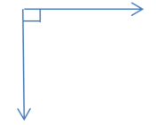 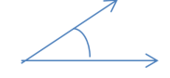

1. 14.

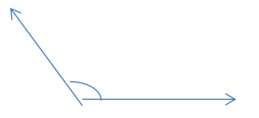 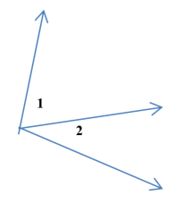 



The $°$ symbol stands for this. Example 98 $°$.