Name:

Date:

School:

Facilitator:

2.05 Adjacent and Congruent Angles

Total Points: 57

**Use the diagram below to answer problems 1-5.**

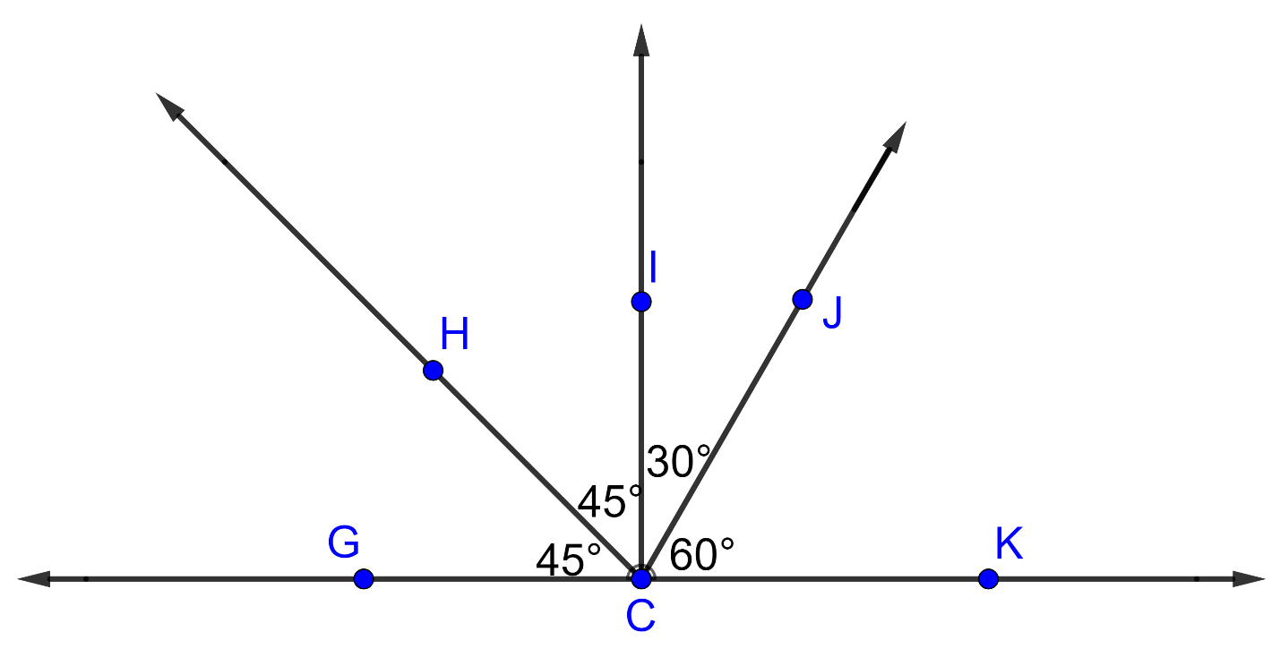

1) Name a pair of adjacent angles.

2) Name a pair of congruent angles.

3) Name an angle bisector.

4) Find the measure of angle HCK.

5) Find the measure of angle GCJ.

6) What is the measure of ∠ABD in the diagram below?       o

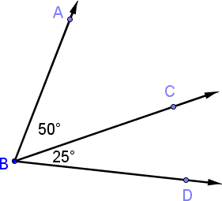

7) What is the measure of ∠WYX in the diagram below?      o

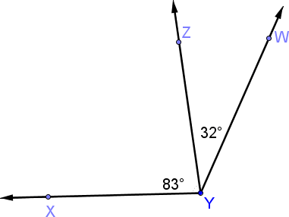

8) What is the measure of ∠MNP in the diagram below?      o

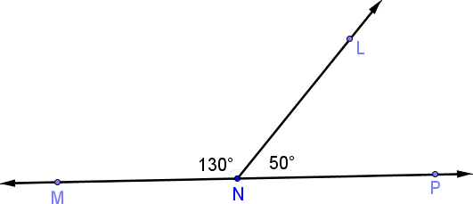

**Use the diagram below to answer problems 9-11.**

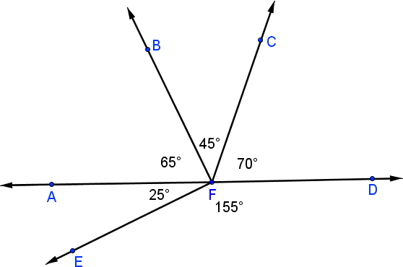

9) What is the measure of ∠BFE in the diagram above?      o

10) What is the measure of ∠AFC in the diagram above?       o

11) What is the measure of ∠BFD in the diagram above?       o

**For 12-13, Ray AB bisects angle CAD. Find the value of x. Show all work.**

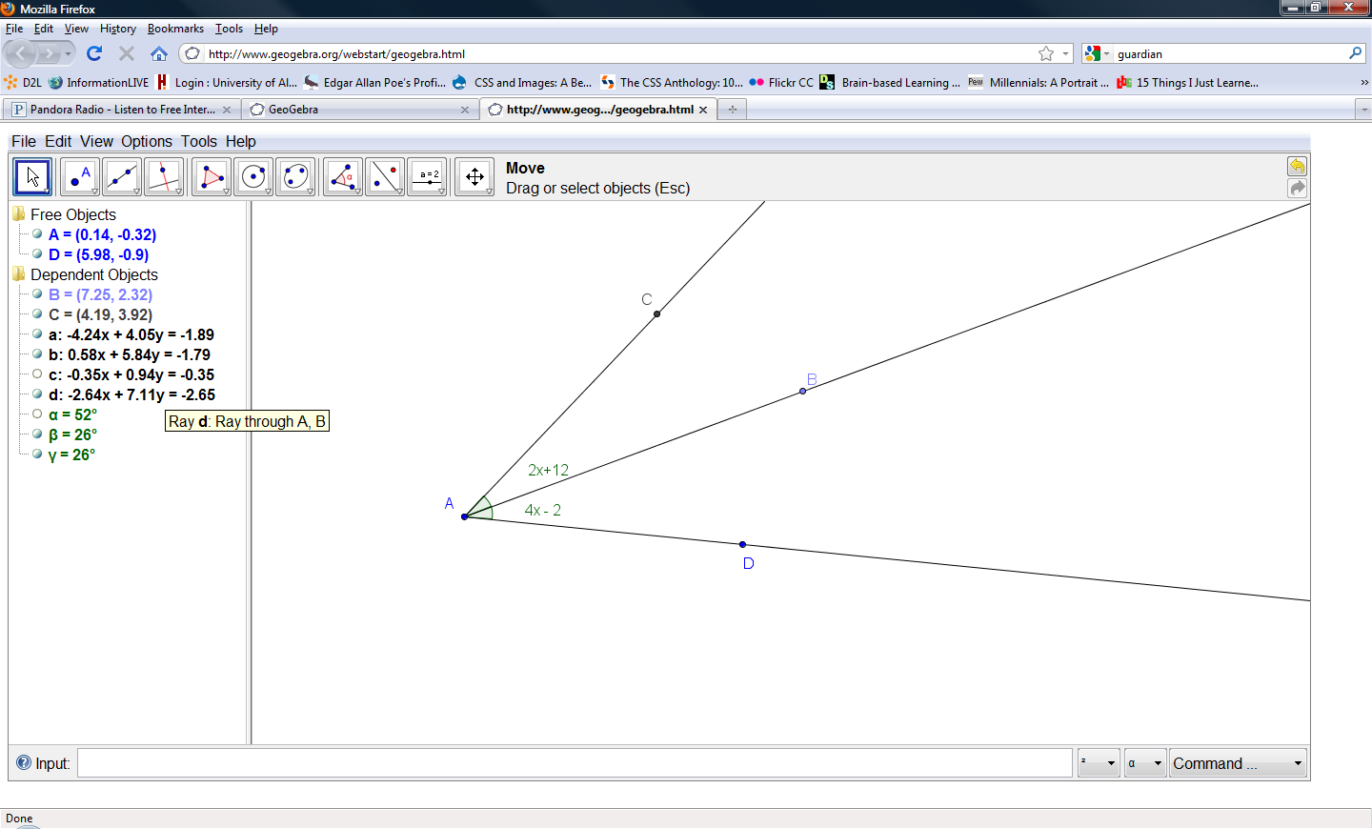12)

Work:

Answer:

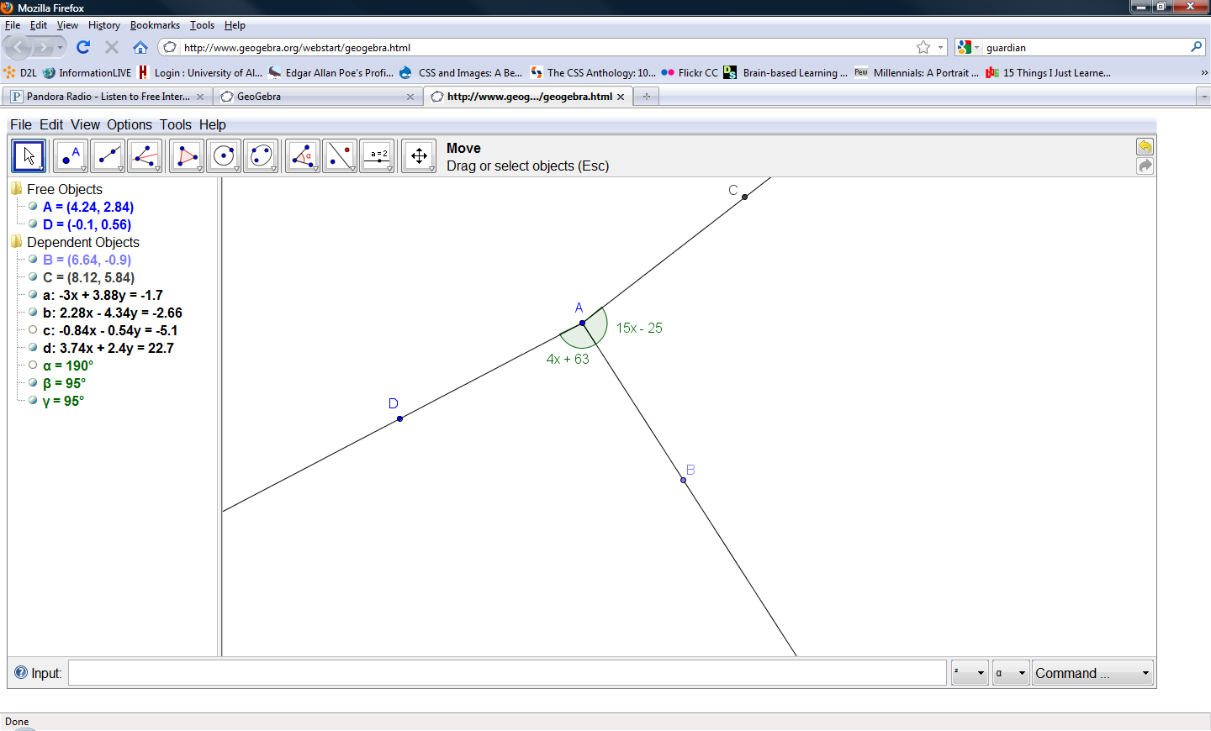

13)

Work:

Answer:      

14) In the diagram below, the *m*∠BAD = 145O, the *m*∠BAC = (4*x*+31)O, and *m*∠CAD = (5*x*+24)O. Find the value of x, *m*∠BAC , and *m*∠CAD. Show all work.

Two adjacent angles BAC and CAD. The measure of angle BCA is 4x + 31 degrees.
The measure of angle CAD is 5x + 24 degrees. The measure of angle BAD is 145 degrees.  

*x* =

Show your work here:

*m*∠BAC =      o

Show your work here:

*m*∠CAD =      o

Show your work here:

15) In the diagram below, $\vec{AC }$ bisects angle BAD Find the value of x, *m*∠BAC , and *m*∠CAD. Show all work.

Two adjacent angles BAC and CAD. The measure of angle BCA is 6X +14 degrees.
The measure of angle CAD is 3x+47 degrees. 

*x* =

Show your work here:

*m*∠BAC =      o

Show your work here:

*m*∠CAD =      o

Show your work here: