Name:

Date:

School:

Facilitator:

2.02 Segment Addition and Distance

Total Points: 41

**Use the number line to find the distance of the line segment. You may use the absolute value of the difference or count the steps.**

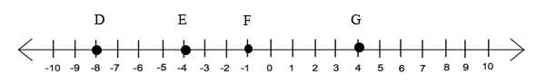

**Find**

1. DE 2. DF 3. EG

Answer:       Answer:       Answer:

*Use the segment addition to find the distance of the given line segment.*

line segment with point A at left end, a distance of 5 is point B, a distance of 5 is point C, a distance of 35 is point D at the left end

35

5

5

**Find**

4. AC 5. AD 6. BD

Answer:       Answer:       Answer:

**Find the distance between the two points to the nearest hundredths place:**

7. (1, 3), (-2, 4)

Answer:

8. (-1,0), (2,-4)

Answer:

**Find the distance between the two points. Write the final answer in simplified form.**

9. (-2,2), (-6,-8)

Answer:

10. In your own words, explain how to use the Pythagorean Theorem derive the distance formula.