Name:

Date:

School:

Facilitator:

2.01 Points, Lines, and Planes

Total Points: 51

**Identify the following figures as a point, a line, a segment, a ray, or a plane. Then, name the figure. Do not use symbols.**

**1.**

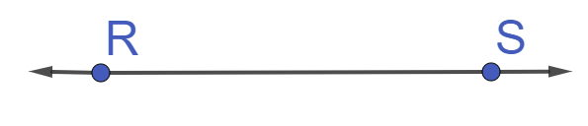

**What is the figure?**

**Name the figure:**

**2.**



**What is the figure?**

**Name the figure:**

**3.**

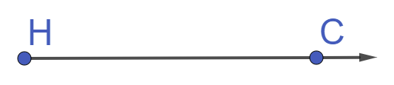

**What is the figure?**

**Name the figure:**

**4.**



**What is the figure?**

**Name the figure:**

**5.**

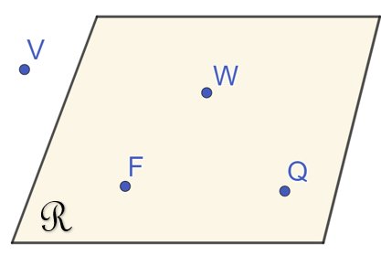

**What is the figure?**

**Name the figure:**

**Use the diagram below to answer problems # 6 – 14.**

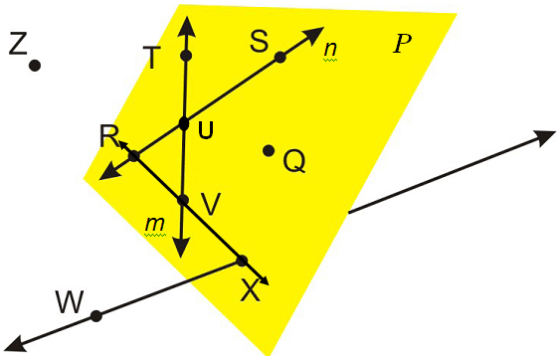

1. Name one set of three collinear points.

     ,      , and      .

1. Name one set of three non-collinear points.

     ,      , and      .

1. Which point is the intersection of $\overset{⃡}{RS}$ and $\overset{⃡}{VT}$?
2. What is another name for the line *m*? Place the appropriate symbol over your answer (Drag the symbols into place).
3. Name two points that are NOT contained in or lying in plane *P*.      and
4. Provide at least two other ways to name plane *P*.      and
5. Name two coplanar lines. Place the appropriate symbols over your answers.      and
6. Name a line that is not contained in plane *P*. Place the appropriate symbol over your answer.
7. Name a ray that has U as its endpoint. Place the appropriate symbol over your answer.

**Use the diagram below to answer problems # 15 – 18.**

*plane that includes the lines JD and NQ. Line JD includes point L. Line NQ intersects the plane at point N. Point K lines on the plane, point M is outside the plane.*

1. Name a point that is collinear with J and L.
2. Name the intersection of plane JDK and line NQ.
3. Name a segment that lies on line JD.
4. Name a ray that lies on line LD with endpoint J.

**Use the diagram below to answer problems # 19 – 24.**

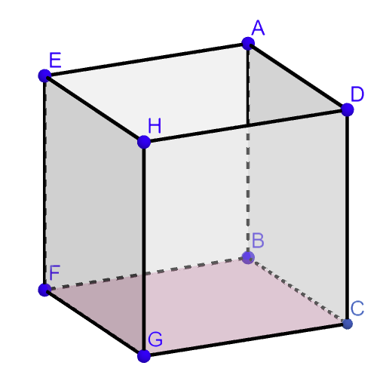

1. Are $\overset{⃡}{FB}$ and $\overset{⃡}{BA}$ parallel lines, perpendicular lines, or skew lines?

1. Are $\overset{⃡}{GC}$ and $\overset{⃡}{FE}$ parallel lines, perpendicular lines, or skew lines?

1. Are $\overset{⃡}{AB}$ and $\overset{⃡}{EF}$ parallel lines, perpendicular lines, or skew lines?

1. Are planes EHD and GCD parallel planes, or perpendicular planes?

1. Are planes EFG and ADC parallel planes, or perpendicular planes?

1. Are planes HDA and FBC parallel planes, or perpendicular planes?

**Use the definition of parallel and perpendicular lines to answer the following question.**

1. Describe the difference between parallel and perpendicular lines.