Name:
Date:
School:
Facilitator:

11.03 Pyramids and Cones
Total points: 30
Find the surface area of each regular pyramid. Don’t forget your units in your answers! It may be necessary to use the Pythagorean Theorem to find the slant height, l.

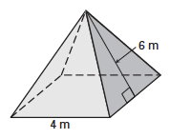 |  | 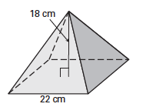 |  | 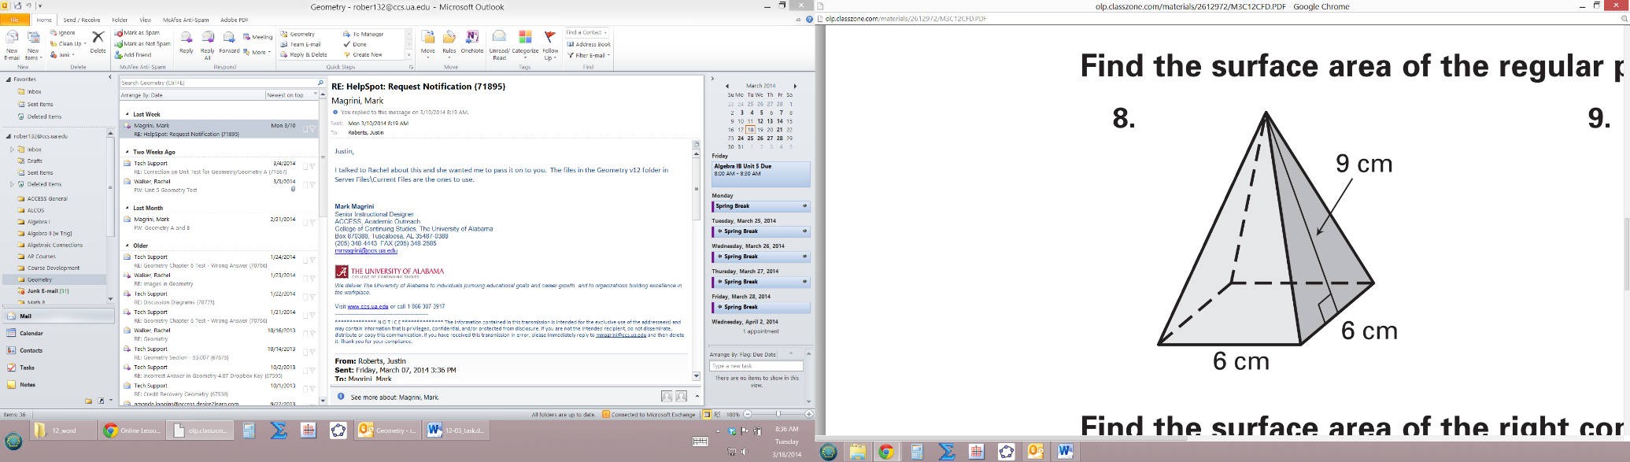
1. SA = |  | 2. SA = |  | 3. SA =

Find the surface area of each cone. Don’t forget your units in your answers! It may be necessary to use the Pythagorean Theorem to find the slant height, l.

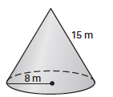 |  | 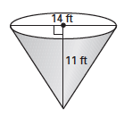 |  | 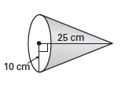
4. SA = |  | 5. SA = |  | 6. SA =

7. A regular pyramid has a height of 8 inches. Its base is an equilateral triangle with a side length of 12 inches. Find the surface area of the pyramid. Show all your work.
Hint: Use $A = \frac{1 }{4}s²\sqrt{3}$ to find the area of the base.
SA =
Show your work below.

8. A right cone has a radius of 3 feet and a height of 9 feet. Find its surface area. Show all your work.
Hint: You will need to use the Pythagorean Theorem to find the slant height, l.
SA =
Show your work below.

