Name:
Date:
School:
Facilitator:

11.01 Exploring Solids
Total points: 32
Tell whether the solid is a polyhedron. If it is, find the number of faces, vertices, and edges.
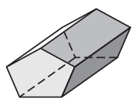 |  | 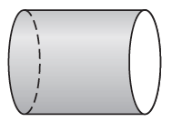 |  | 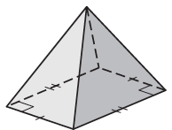
1. Is this a polyhedron?  Number of Faces =  Number of Vertices =  Number of Edges = |  | 2. Is this a polyhedron?  Number of Faces =  Number of Vertices =  Number of Edges = |  | 3. Is this a polyhedron?  Number of Faces =  Number of Vertices =  Number of Edges =

Describe the shape formed by the cross section.
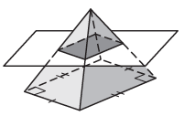 |  | 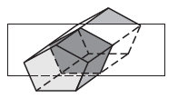 |  | 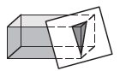
4. The shape is a |  | 5. The shape is a |  | 6. The shape is a
Use Euler’s Theorem to find the unknown number.
7. Faces = 32  Vertices =  Edges = 90 |  | 8. Faces =  Vertices = 6  Edges = 10 |  | 9. Faces = 5  Vertices = 5  Edges =
10. A solid has 6 faces, 5 triangles and 1 pentagon. Use Euler’s Theorem to find the number of vertices.
Vertices =

