Name:

Date:

School:

Facilitator:

2.03: Linear Equations from Graphs

# Total Points: 40

1. Write an equation of a line in slope intercept form using the graph below.

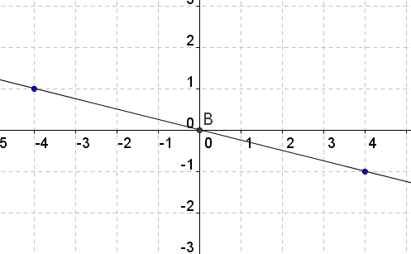

Work:     

Answer:      

2. Write an equation of a line in slope intercept form using the graph below.

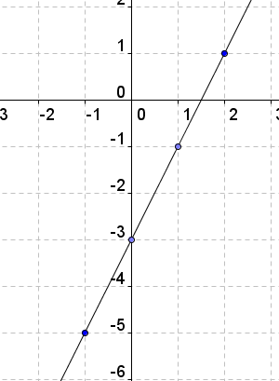   
Work:      

Answer:      

3. Write an equation of a line in slope intercept form using the table of values below.

|  |  |
| --- | --- |
| **x** | **y** |
| - 2 | 7 |
| - 1 | 5 |
| 0 | 3 |
| 1 | 1 |
| 2 | - 1 |

Work:      

****Answer:      

4) Write an equation of a line in slope intercept form using the table of values below.

|  |  |
| --- | --- |
| **CD’s**  **Sold** | **Profit in $** |
| 10 | 50 |
| 15 | 75 |
| 18 | 90 |
| 20 | 100 |
| 25 | 125 |

Work:      Answer:      

5) Using your equation from problem 4, how many CDs must you sell to earn a minimum profit of $2000?

Work:      Answer:      

6) Write the equation in slope intercept form. 3x – 2y = 9

7) Write the equation in slope intercept form. 4x + 2y = -10