Name:

Date:

School:

Facilitator:

2.02 Linear Equations from Points

# Total Points: 50

1. Write an equation of a line in slope intercept form (y = mx + b) with slope -3 going through the point (2, - 2). Show your work for full credit.

1. Write an equation of a line in slope intercept form (y = mx + b) with slope 1/3 going through the point (-6, 2). Show your work for full credit.

1. Write an equation of a line in slope intercept form (y = mx + b) going through the points (2, 1) and (- 1, - 5). Show your work for full credit.

1. Write an equation of a line in slope intercept form (y = mx + b) going through the points (- 2, 0) and (4, - 3). Show your work for full credit.

1. Write an equation of the line shown in the graph in slope intercept form (y = mx + b). Show your work for full credit. 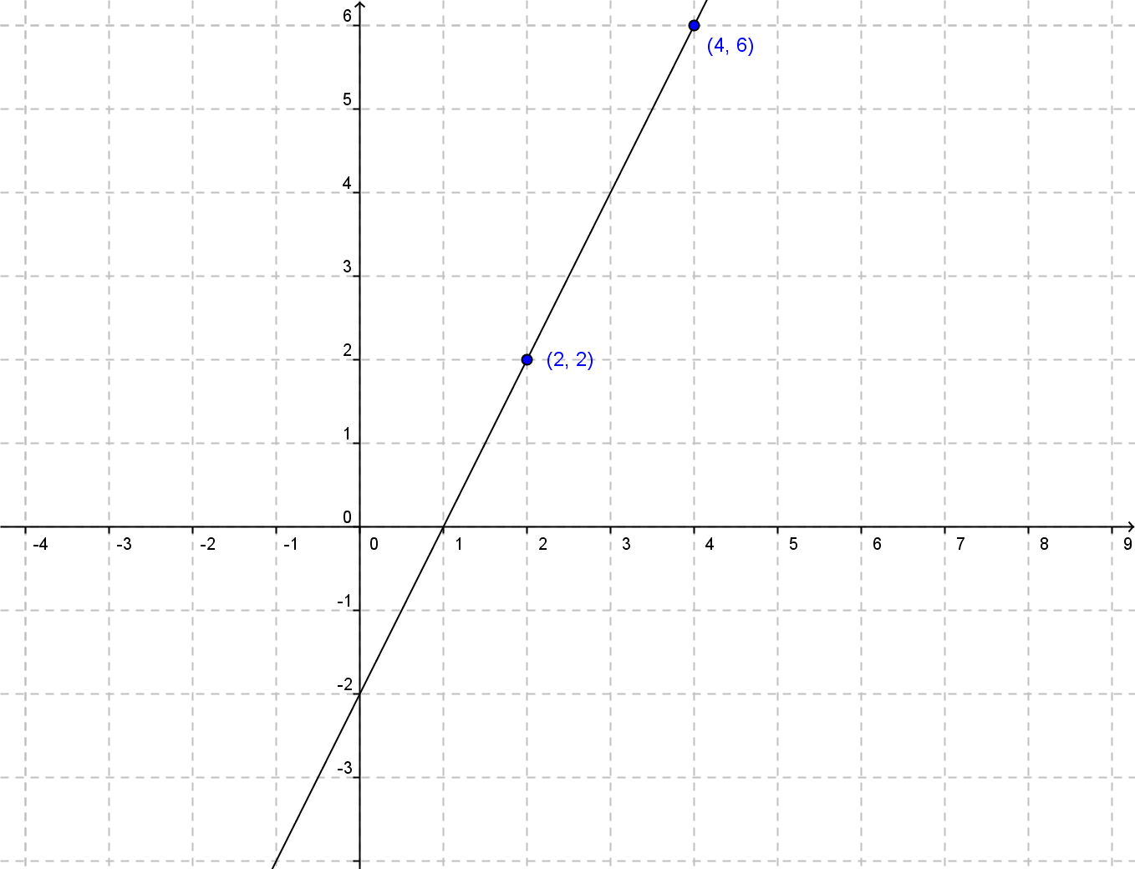
2. **Write an equation of the line shown in the graph in slope intercept form (y = mx + b). Show your work for full credit.** 