Name:

Date:

School:

Facilitator:

2.02 Linear Equations Additional Practice Key

Here are some additional practice problems to help you. You will not turn these in. They are just to help you better understand.

1. Which of the following does *Ax* + *By* = *C* represent?
2. slope
3. standard form
4. slope intercept form
5. y intercept

**Answer**: standard form

1. Which of the following does *b* represent?
2. slope
3. standard form
4. slope intercept form
5. y intercept

**Answer**: y intercept

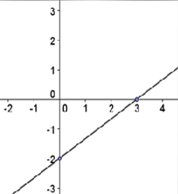

1. What is the y intercept of this line?
2. -2
3. 2
4. -3
5. 3

**Answer**: -2

1. 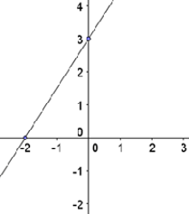What is the y intercept of this line?
2. -2
3. 2
4. -3
5. 3

**Answer**: -2

1. 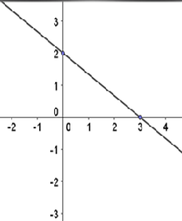What is the slope of this graph?
2. m = 2/3
3. m = -2/3
4. m = 3/2
5. m = -3/2

**Answer**: m = -2/3

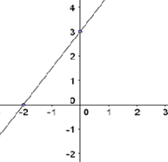

1. What is the slope of this graph?
2. m = 2/3
3. m = -2/3
4. m = 3/2
5. m = -3/2

**Answer**: m = 3/2

1. Write a linear equation *y = mx + b* for the following information: m = 1, b = 4
   1. *y* = 4*x* + 1
   2. *y* = -1*x* + 4
   3. *y* = *x* - 4
   4. *y* = *x* + 4

**Answer**: *y* = *x* + 4

1. Write a linear equation *y = mx + b* for the following information: (1, -5) and (-3, 7)
   1. *y* = -3*x* - 2
   2. *y* = -3 - 2
   3. *y* = 1/3*x* + 3/3
   4. *y* = 1/3*x* + 16/3

**Answer**: *y* = -3*x* - 2