Name:

Date:

School:

Facilitator:

2.01 Slope of a Line

# Total Points: 50

1) What does slope of a line describe?   
A) Length   
B) Height   
C) Steepness

Answer:



2) If you were traveling from left to right on a line and you said you were going uphill would the slope be positive or negative?  
Answer:

3) What move does the numerator of the slope describe?   
A) Left or Right   
B) Up or down

Answer:

4) What move does the denominator of the slope describe?   
A) Left or Right

B) Up or down  
Answer:

5) Find the slope between the points (3, 2) and (5, 4). Show your work.

6) Find the slope between the points ( - 4, 1) and ( - 2, - 6). Show your work.

7) What is the slope in the equation y = -6x + 4?

Answer:

8) What is the y-intercept in the equation y = x – 5?

Answer:

9) Write the equation 2x + 4y = 12 in slope intercept form. Show your work.

10) Write the equation x – 3y = 6 in slope intercept form. Show your work.

11) Match the equation $y=\frac{1}{3}x-2$ to the graph below:  
Answer:

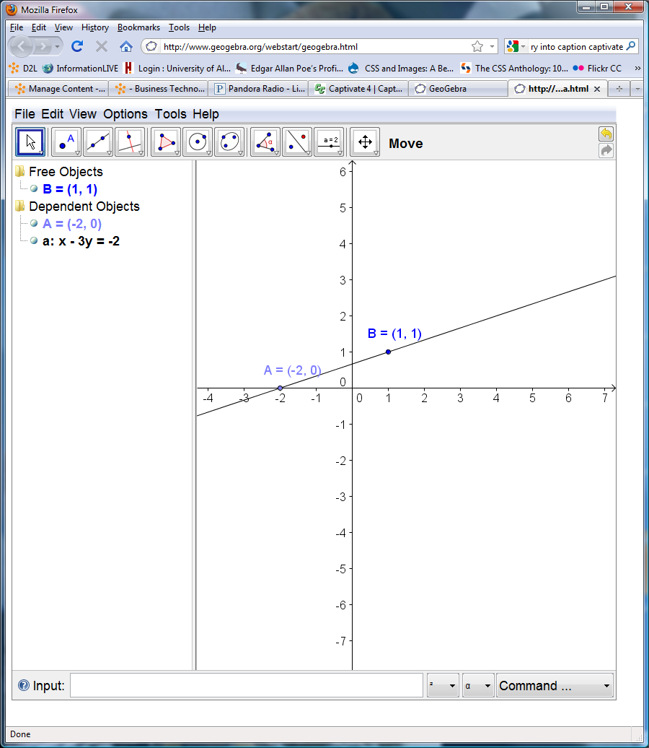 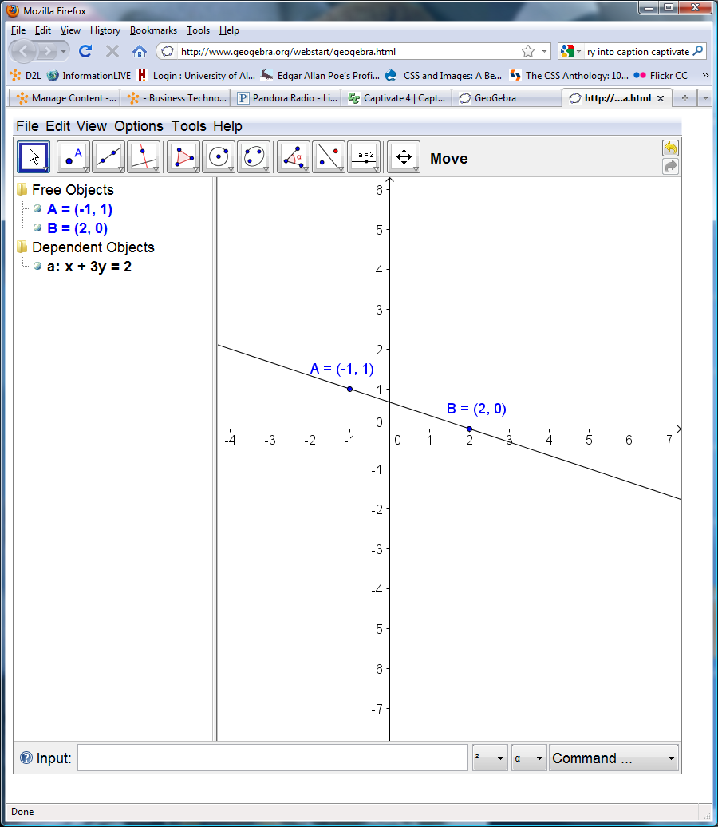

**B**

**A**

**D**

**C**

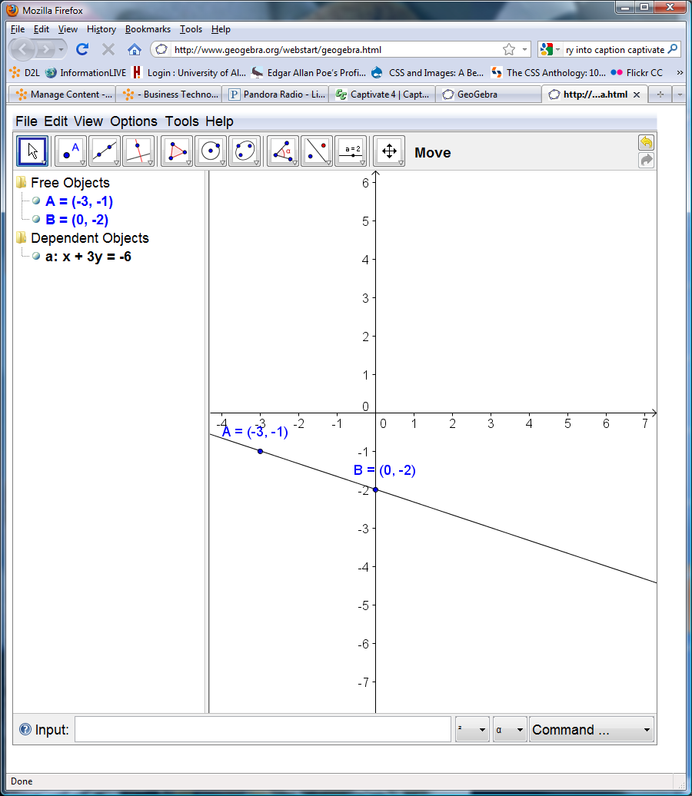 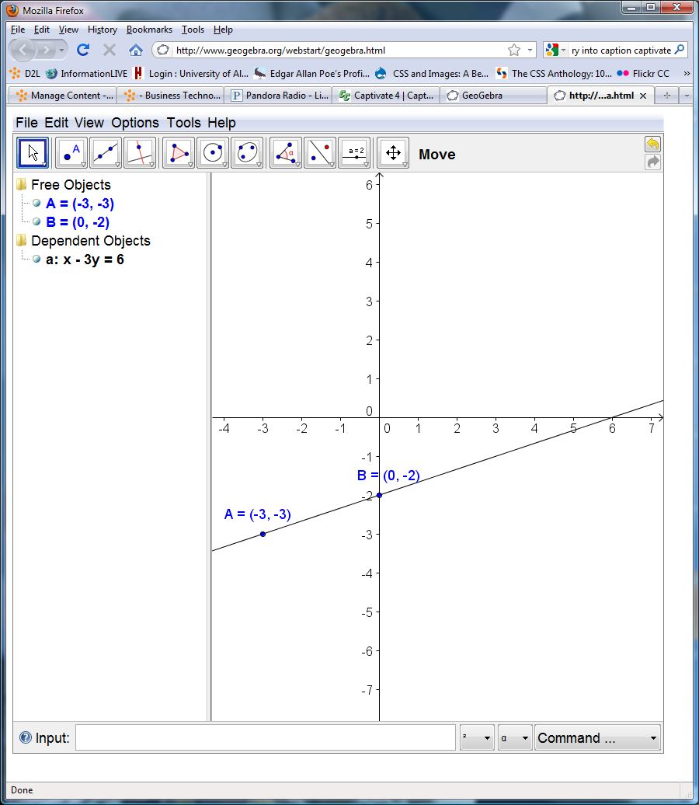

12) Match the equation y = 2x to the graph below:

Answer:

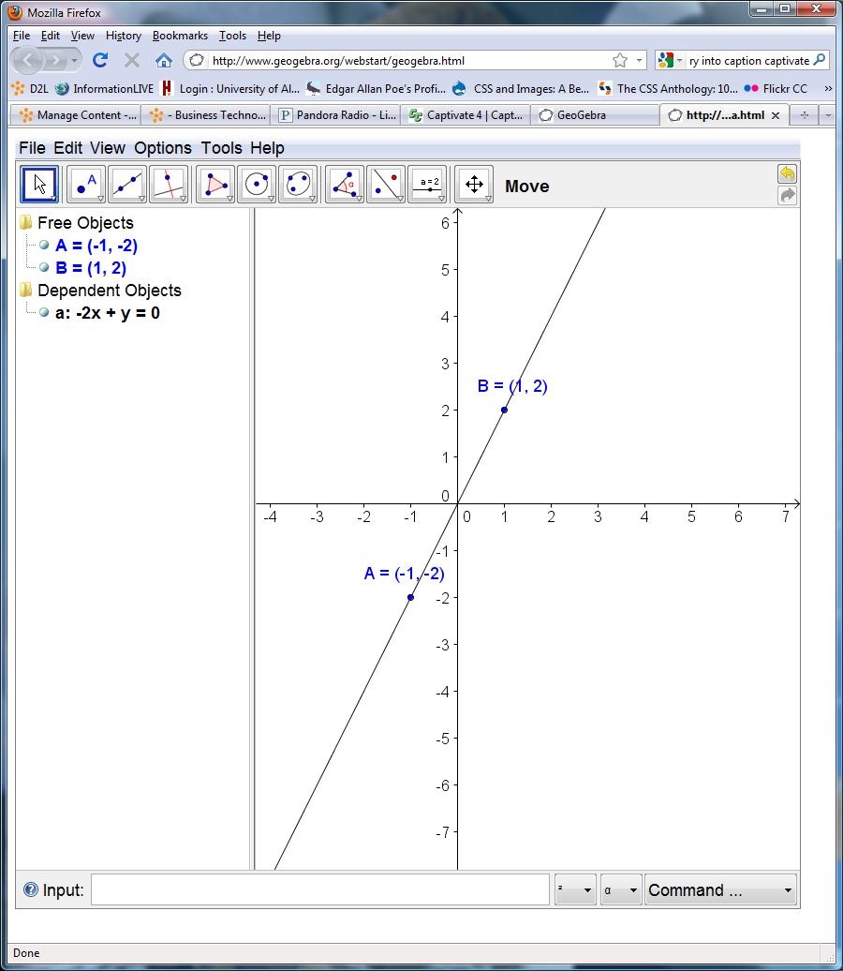 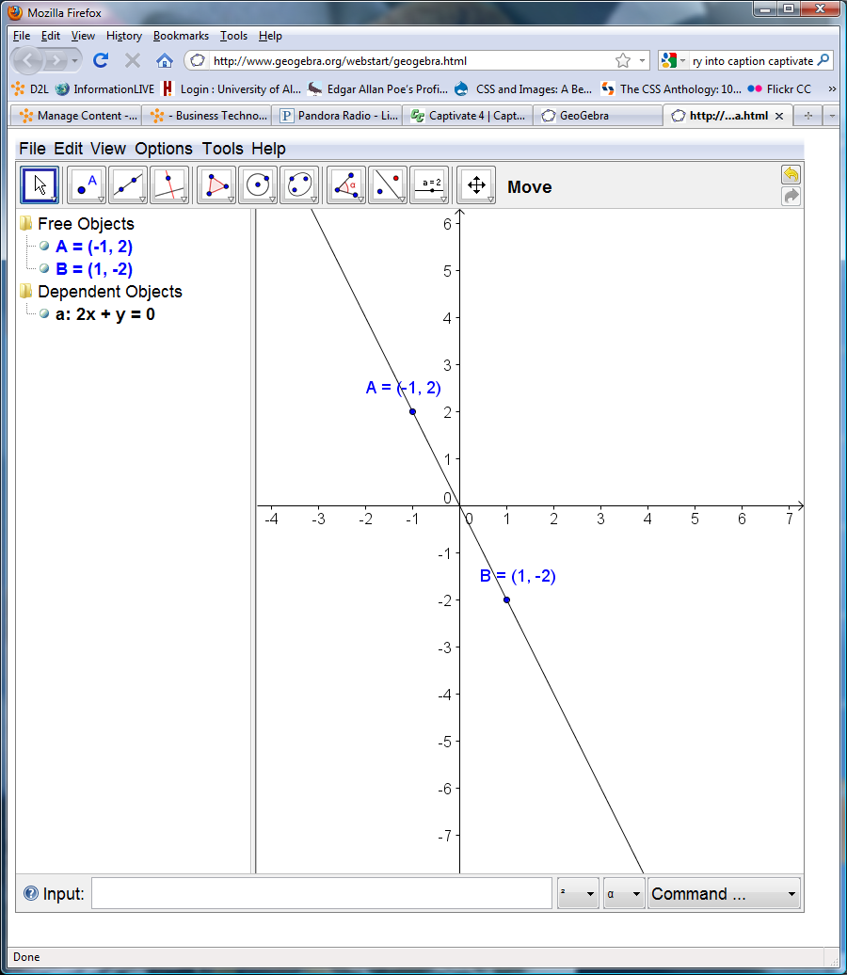

**B**

**A**

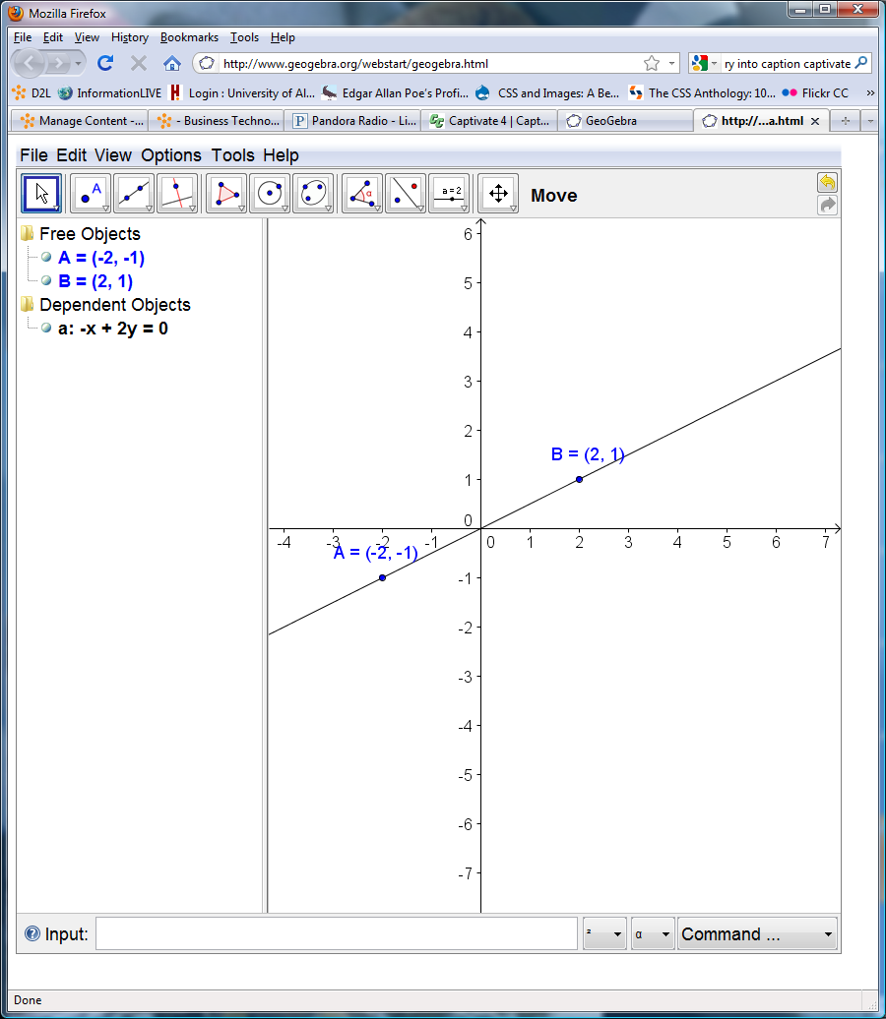 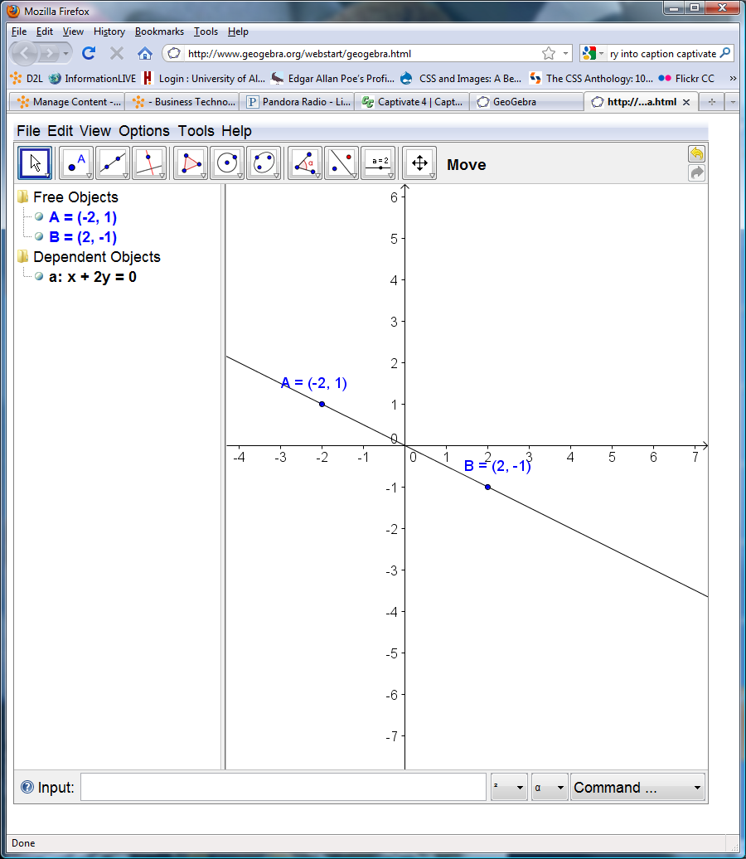

**D**

**C**