Name:
Date:
School:
Facilitator:

4.07 Study Guide
Match the terms to their definitions.
1. Corresponding a. Exactly the same including size and shape
2. SAS b. Positioned in a similar fashion and location
3. SSS c. Side-Side-Side congruency postulate
4. Congruent d. Side-Angle-Side congruency postulate
5. AAS e. Angle-Side-Angle congruency postulate
6. ASA f. Angle-Angle-Side congruency postulate

Drag the symbols to mark the triangles below.
7. Mark the triangles such that 8. Mark the triangles such that
∠A ≅ ∠R ; AB ≅ RT ; ∠B ≅ ∠T AB ≅ RT ; AC ≅ RS ; CB ≅ ST
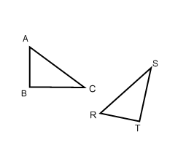
What congruency type is this? What congruency type is this?

9. Mark the triangles such that 10. Mark the triangles such that
∠A ≅ ∠R ; BC ≅ TS ; ∠C ≅S ∠A ≅ ∠R ; AC ≅ RS ; AB ≅ RT
What congruency type is this? What congruency type is this?

11. What if we can find that all three angles have a corresponding congruent match? (AAA)
Does this prove congruency? Explain your reasoning.

