Name:

Date:

School:

Facilitator:

8.01 Altitudes

1. Find the geometric mean between 4 and 25. Show your work.

|  |  |  |
| --- | --- | --- |
|  | = |  |
|  |  |

x =

2. Find the geometric mean between 4 and 1/4. Show your work.

|  |  |  |
| --- | --- | --- |
|  | = |  |
|  |  |

x =

*Find the value of h, x, and y in the following problems.*

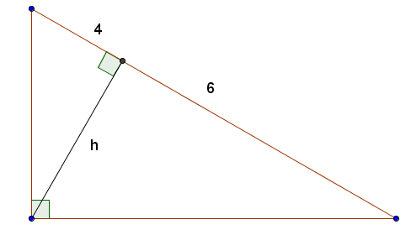

3. Find h

h =

4. John and Carol have both set up a proportion to solve for x in the diagram below.

John :  Carol:   
Who is correct? Then solve for x.

**Who is correct?**

**x =**

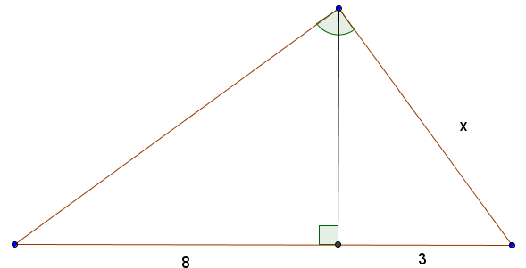

5. Find x and h.

x =

h =

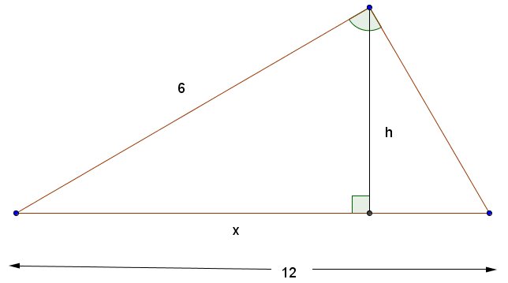

y