Name:

Date:

School:

Facilitator:

7.02 Similar Polygons

1. LMNO and PQRS are similar. List all pairs of congruent angles and write the statement of proportionality for the figures.

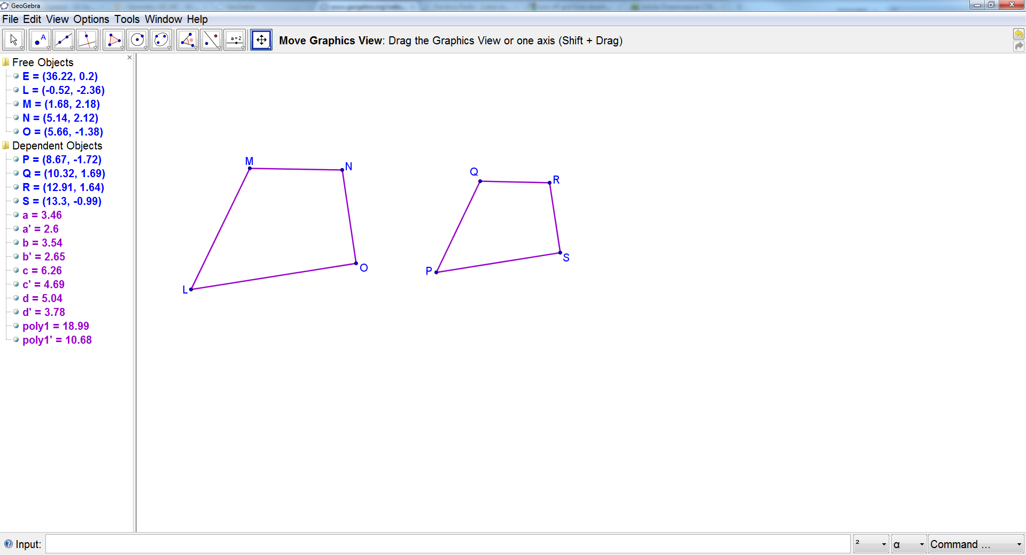

∠      ≅∠

∠      ≅∠

∠      ≅∠

∠      ≅∠

     /      =      /      =      /      =      /

2. EFGHI and JKLMN are similar. List all pairs of congruent angles and write the statement of proportionality for the figures.

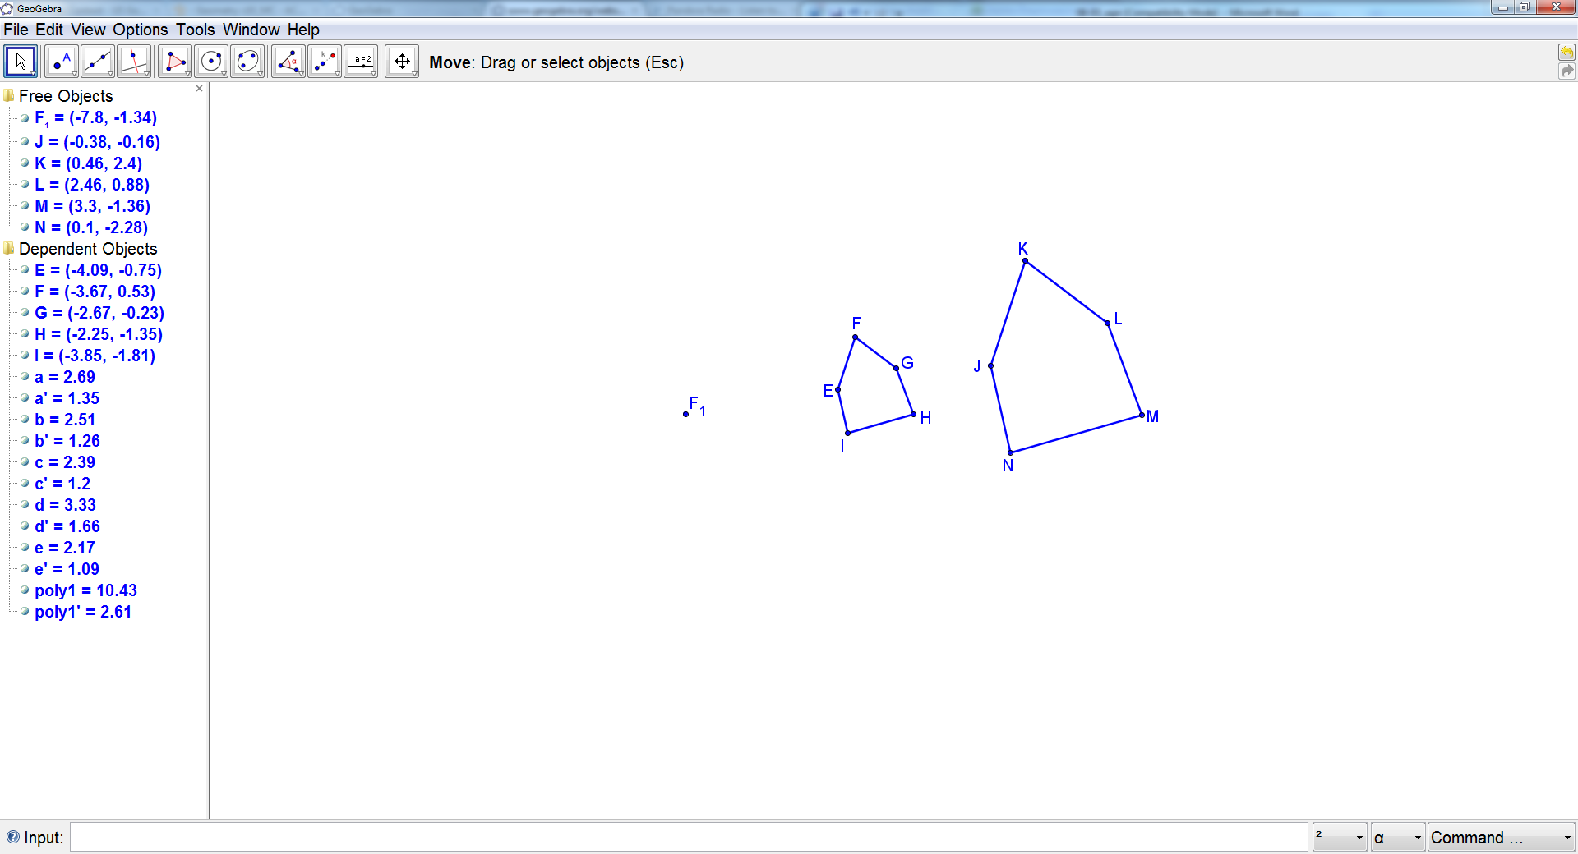

∠      ≅∠

∠      ≅∠

∠      ≅∠

∠      ≅∠

∠      ≅∠

     /      =      /      =      /      =      /      =      /

3. Decide whether the polygons are similar, not similar, or not enough information is given.

If similar, write a similarity statement. If not, explain why.

**Answer:**

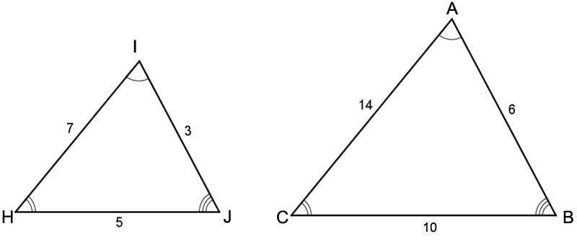

4. Decide whether the polygons are similar, not similar, or not enough information is given.

If similar, write a similarity statement. If not, explain why.

Answer:

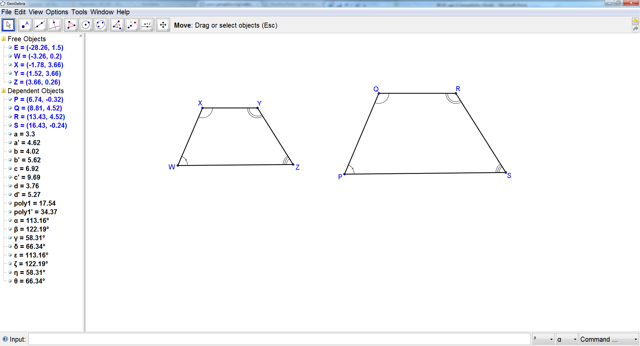

5. Decide whether the polygons are similar, not similar, or not enough information is given.

If similar, write a similarity statement. If not, explain why.

Answer:

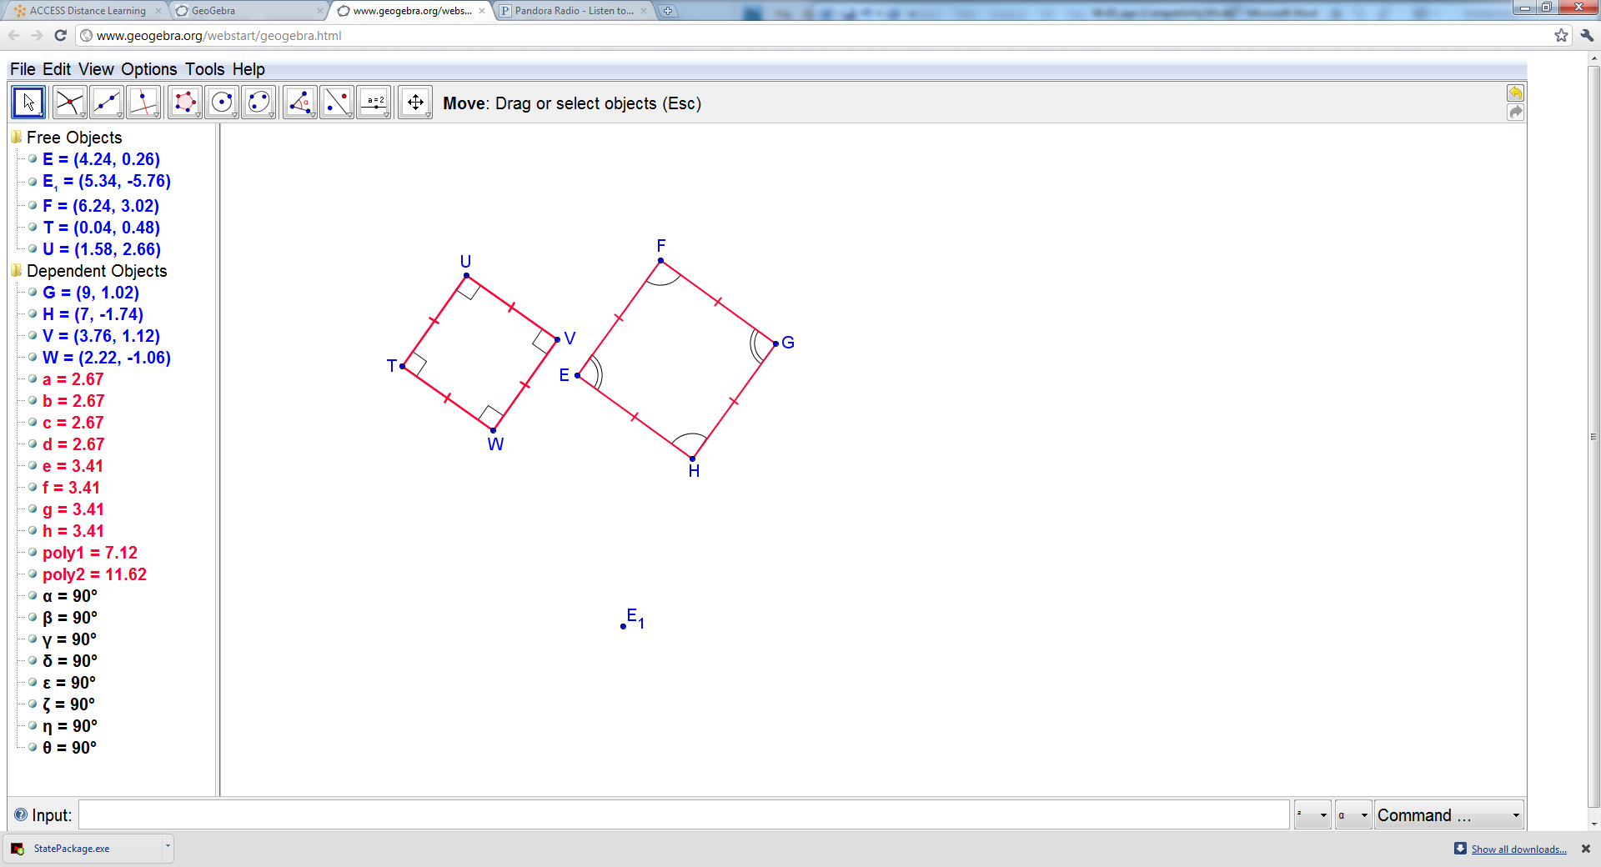

6. RSTU and MNOP are similar. Find the scale factor of RSTU to MNOP. Then find the values of x and y.

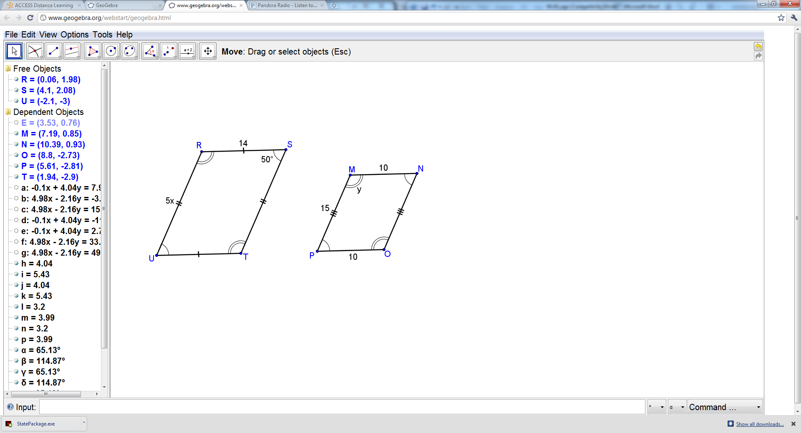

Scale factor:

x =

y =