Name:
Date:
School:
Facilitator:

6.01 Transformations
Part 1: Name the transformation: Reflection, Rotation or Translation:

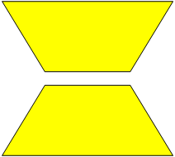 |  | 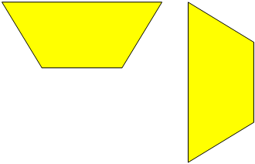
1. Type of transformation: |  | 2. Type of transformation:
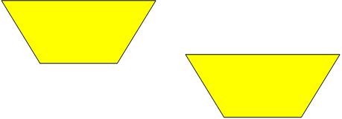
3. Type of transformation:

Part 2: Reflection: State if the figure has a reflection that carries onto itself. If so state how many lines of symmetry the figure has.

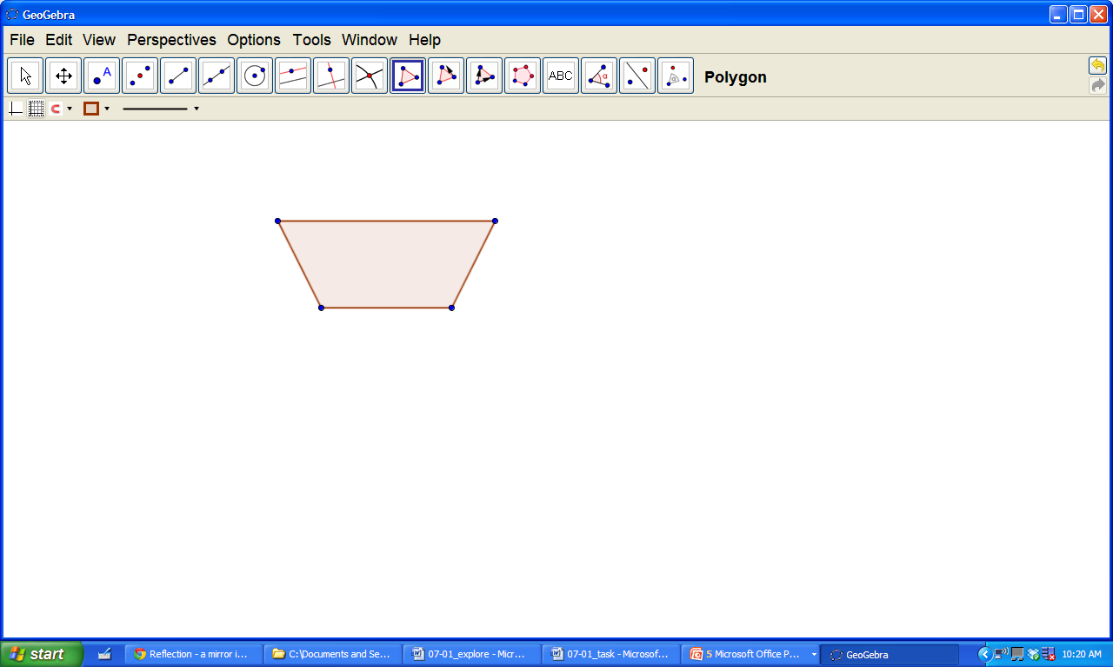 | 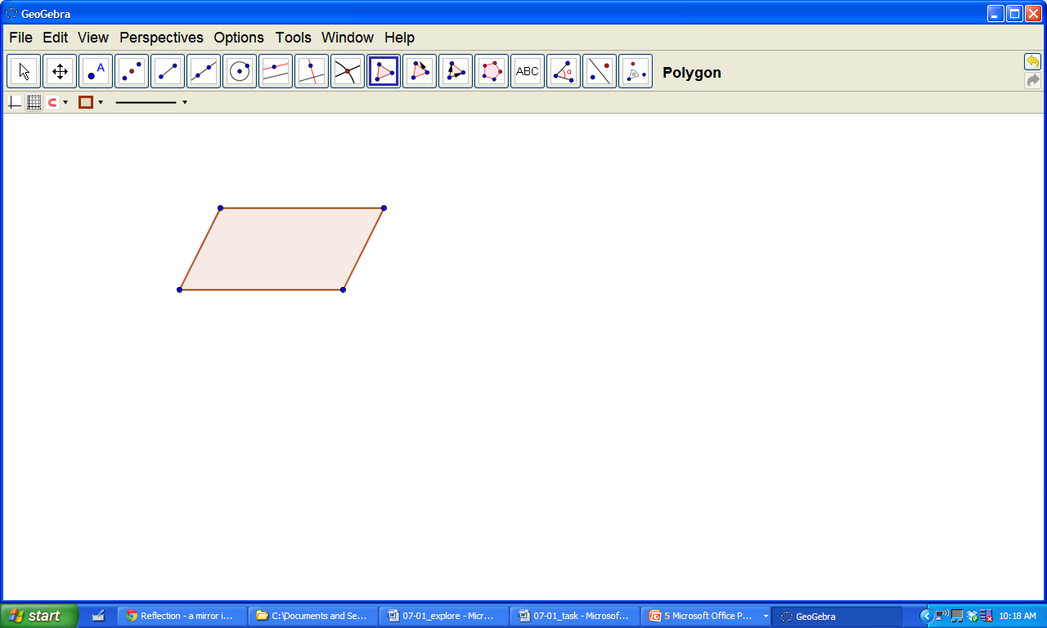 | 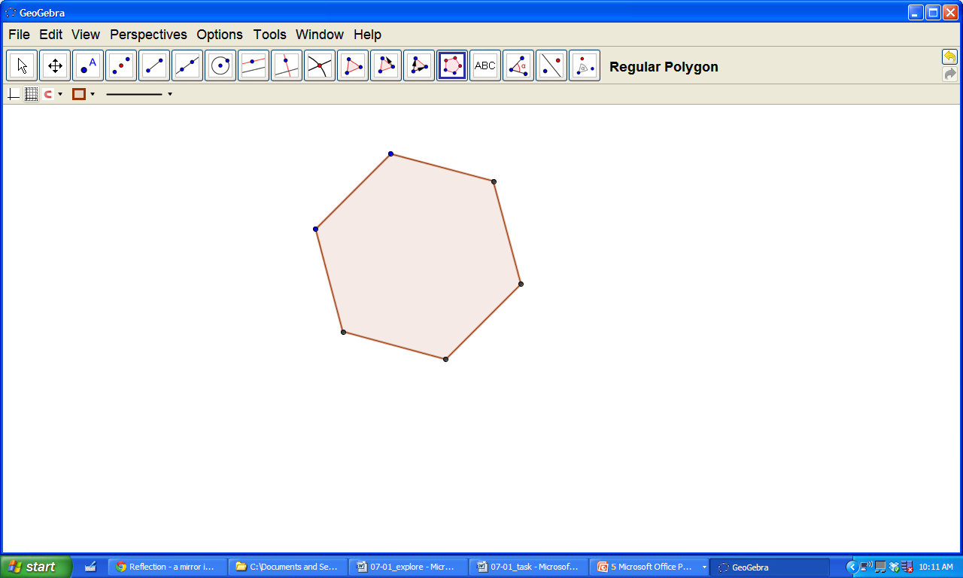
4. Does this figure have a reflection that carries onto itself?  If so, how many lines of symmetry have? | 5. Does this figure have a reflection that carries onto itself?  If so, how many lines of symmetry have? | 6. Does this figure have a reflection that carries onto itself?  If so, how many lines of symmetry have?

Rotation: State if the above figure has a rotation that it carries onto itself. If so describe the rotation as a 90⁰, 180⁰ or 270⁰ turn.

7. Does this figure have a rotation that carries onto itself?  If so, is it 90°, 180°, or 270°? | 8. Does this figure have a rotation that carries onto itself?  If so, is it 90°, 180°, or 270°? | 9. Does this figure have a rotation that carries onto itself?  If so, is it 90°, 180°, or 270°?

10. What does isometry mean?

11. Write a short paragraph comparing these three transformations. What do they have in common? How are they different?

