Name:

Date:

School:

Facilitator:

5.05 Trapezoids

1. Find the angle measures of the missing angles.

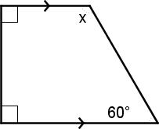

x =

1. Segment RT is the midsegment of the trapezoid. Find x.

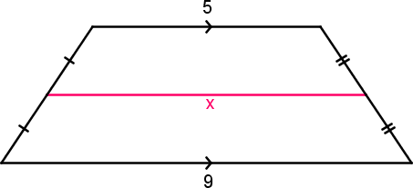

S**R**

**T**

x =

1. Segment RT is the midsegment of the trapezoid. Find x.

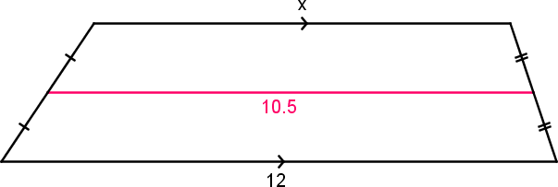

**R**

**T**

x =

1. Find the midsegment of trapezoid ABCD given that A(1,1), D(5,1), C(4,8), and B(2,8).   
     
   a. State the coordinates of the endpoints of the midsegment. Show your work!

(      ,      ) and (      ,      )  
  
b. Verify that the midsegment is parallel to the bases of ABCD. Show your work!  
Slope of AD =

Slope of BC =        
Slope of midsegment =        
  
c. Verify that the length of the midsegment is half the sum of the lengths of the bases. Again, Show your work.

Length of AD =

Length of BC =        
Sum of length of bases:

Length of midsegment:

