Name:

Date:

School:

Facilitator:

5.05 Study Guide

**Match the terms to their definitions.**

1. Quadrilateral

2. Base Sides

3. Legs

4. Trapezoid

5. Midsegment

6. Diagonals

a. The two parallel sides of a trapezoid

b. Line segments that connect two non-adjacent vertices

c. A segment that connects the mid-points of the legs of a trapezoid

d. A four-sided polygon

e. A quadrilateral with exactly one set of parallel sides

f. The two non-parallel sides of a trapezoid

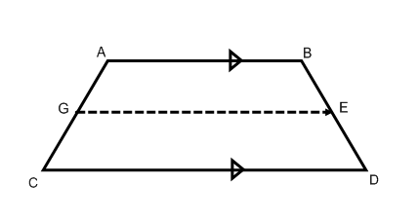

7. In trapezoid ABDC, if m∠CAB=125°, solve for ∠ACD. m∠ACD = °

8. In trapezoid ABCD, if AB = 18 and CD = 24, solve for the mid-segment GE. GE =

9. In trapezoid ABCD, if GE is a midsegment and ED = 9, find the measure of BD. BD =

10. In isosceles trapezoid ABCD, find the measure of AC if BD = 10. AC =

11. In isosceles trapezoid ABCD, if m∠EDC=44°, find the measure of ∠ACD and ∠DBA.

m∠ACD = °

m∠DBA = °

**Imagine a trapezoid MNOP, where M(9,1), N(7,7), O(3,7) and P(3,1)**

12. Find the coordinates of a midsegment for this trapezoid.   
(,) and (,)

13. Find the measure of the bases … MP and NO

MP =  and NO =

14. Find the measure of the midsegment two ways, by using the mid-segment formula and with the distance formula.   
midsegment =