Name:

Date:

School:

Facilitator:

4.08 Proving Triangles Congruent Part 2

**List the included side between the given angles.**

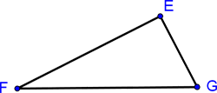

1. ∠F and ∠G:

2. ∠F and ∠E:

**Is there enough information to prove the triangles congruent (yes or no). If yes, list ASA or AAS as the method used to prove them congruent. Fill in the congruent parts and the congruence statement. Then identify the rigid transformation: Reflection, Rotation, or Translation.**

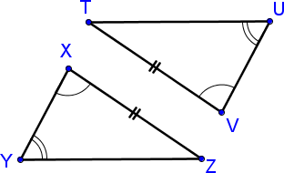

3. **Are the triangles congruent?**

**Method used:**

**Identify the congruent parts.**

      ≅

      ≅

      ≅

      ≅       by       Postulate

**Transformation:**

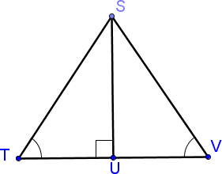

4. **Are the triangles congruent?**

**Method used:**

**Identify the congruent parts.**

      ≅

      ≅

      ≅

      ≅       by       Postulate

**Transformation:**