Name:
Date:
School:
Facilitator:

4.05 Isosceles and Equilateral Triangles
Solve for each variable. Show your work and explain in paragraph form how you solved each problem.
- Base Angles Theorem
- Converse to Base Angles Theorem
- Corollary
- Converse to the corollary
- Sum of Interior Angles
- Exterior angles

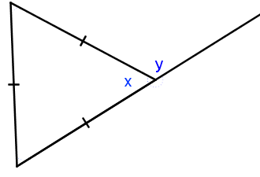 | 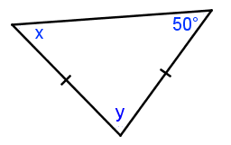
1. x =  y =  Explanation:  Show your work below: | 2. x =  y =  Explanation:  Show your work below:
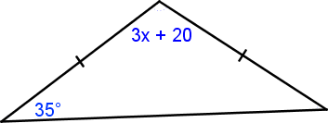 | 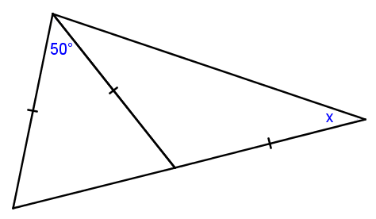
3. x =  Explanation:  Show your work below: | 4. x =  Explanation:  Show your work below:
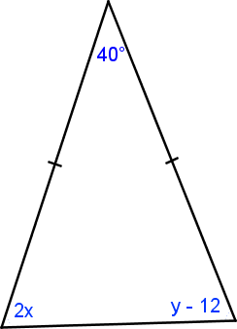

5. x =
y =
Explanation:
Show your work below:

