Name:

Date:

School:

Facilitator:

4.05 Study Guide

**Match the terms to their definitions.**

1. Isosceles Triangle a. The two congruent sides of an isosceles triangle

2. Legs b. A transformation performed by turned a figure around a point

3. Base Angles c. The third side of an isosceles triangle, not congruent to any other side

4. Vertex Angle d. The two congruent angles of an isosceles triangle

5. Base e. Movements of a figure to create an image of the figure

6. Transformations f. The third, non-congruent, angle of an isosceles triangle

7. Rotation g. A transformation performed by flipping a figure across a line

8. Reflection h. An additional property resulting as a consequence to a theorem

9. Corollary i. A triangle with two congruent sides and two congruent angles

10. Base Angle Theorem j. In an isosceles triangle the two angles opposite the congruent

sides are congruent

11. Which of the following triangles is the isosceles triangle?

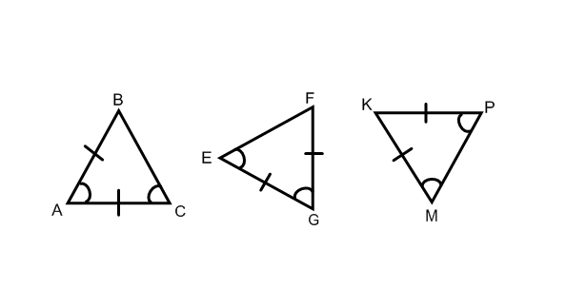

12. Imagine an equilateral triangle with vertices R, S and T. If side RS = 5x + 2 and side TS = 3x+10 , which of the following expressions could represent side RT?

8x or 7x-6 or x+22 or 4x-1