Name:
Date:
School:
Facilitator:

4.04 Triangles and Angles
Classify each triangle by its sides and angles.
Sides: scalene, isosceles, equilateral
angles: acute, obtuse, right, equiangular

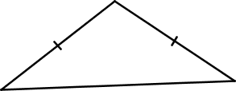 | 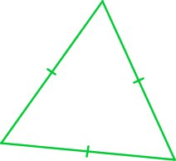 | 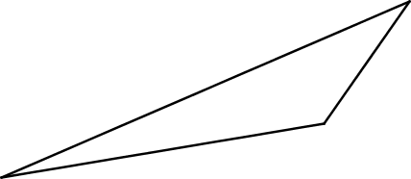
1. Sides:  Angles: | 2. Sides:  Angles: | 3. Sides:  Angles:
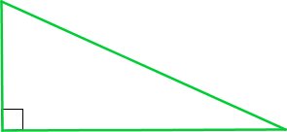 | 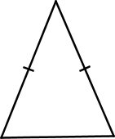
4. Sides:  Angles: | 5. Sides:  Angles:

Find x and classify each triangle by its angles. Provide the theorem (sum of interior angles or exterior angle theorem) you used to solve the problem.

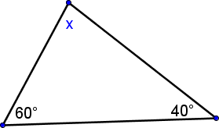 | 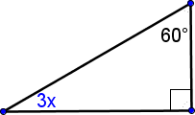
- x =  classification by angles:  Theorem: | - x =  classificationby angles:  Theorem:
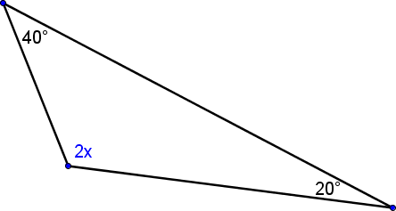 | 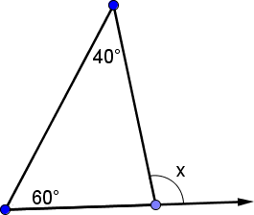
- x =  classificationby angles:  Theorem: | - x =  classificationby angles:  Theorem:
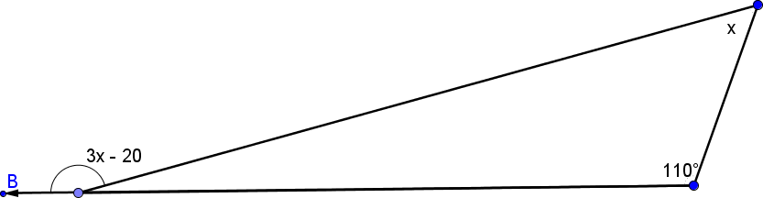
45⁰
- x =
classification:
Theorem:

