Name:
Date:
School:
Facilitator:

4.01 Polygons
Answer the questions below for each image.

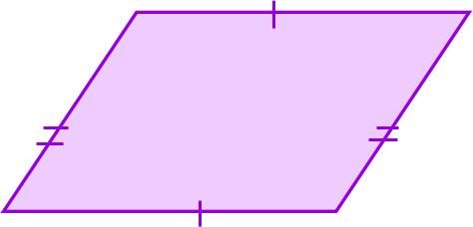 |  | 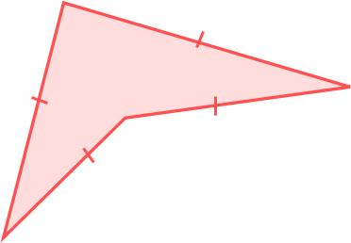 | 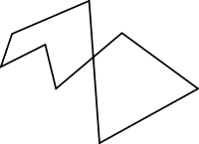
1. Is this figure a polygon?  Answer the questions below only if the figure is a polygon.  1a. Is this polygon concave or convex?  1b. Is this polygon regular, equiangular, equilateral, or none of these?  1c. What is the name of this polygon? | 2. Is this figure a polygon?  Answer the questions below only if the figure is a polygon.  2a. Is this polygon concave or convex?  2b. Is this polygon regular, equiangular, equilateral, or none of these?  2c. What is the name of this polygon? |  | 3. Is this figure a polygon?  Answer the questions below only if the figure is a polygon.  3a. Is this polygon concave or convex?  3b. Is this polygon regular, equiangular, equilateral, or none of these?  3c. What is the name of this polygon?
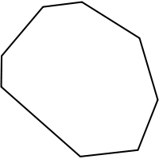 | 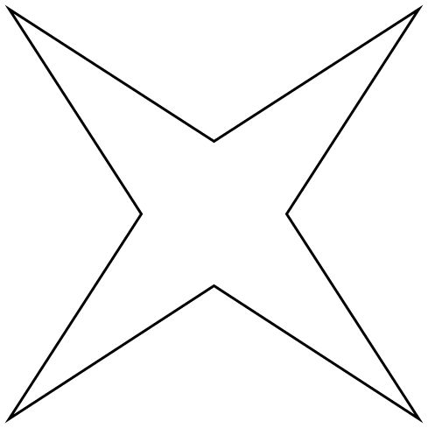  All sides are congruent. |  | 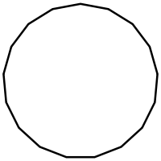  All sides and angles are congruent.
4. Is this figure a polygon?  Answer the questions below only if the figure is a polygon.  4a. Is this polygon concave or convex?  4b. Is this polygon regular, equiangular, equilateral, or none of these?  4c. What is the name of this polygon? | 5. Is this figure a polygon?  Answer the questions below only if the figure is a polygon.  5a. Is this polygon concave or convex?  5b. Is this polygon regular, equiangular, equilateral, or none of these?  5c. What is the name of this polygon? |  | 6. Is this figure a polygon?  Answer the questions below only if the figure is a polygon.  6a. Is this polygon concave or convex?  6b. Is this polygon regular, equiangular, equilateral, or none of these?  6c. What is the name of this polygon?
7. Identify the term that does not belong with the other three. Explain your reasoning.
Square
triangle
circle
hexagon

