Name:

Date:

School:

Facilitator:

3.04 Proving Lines Parallel

**Are lines x and y parallel? State your reasoning for each answer.**

x

|  |  |
| --- | --- |
| Description: 05-04_agn1  y  x | Description: 05-04_agn2  y |
| 1. Are lines x and y parallel? (yes / no) :       Reason: | 1. Are lines x and y parallel? (yes / no) :       Reason: |
|  |  |
| Description: 05-04_agn3  y  x | Description: 05-04_agn4  y  x |
| 1. Are lines x and y parallel? (yes / no) :       Reason: | 1. Are lines x and y parallel? (yes / no) :       Reason: |
|  |  |
| Description: 05-04_agn5  y  y  x  x | Description: 05-04_agn6 |
| 1. Are lines x and y parallel? (yes / no) :       Reason: | 1. Are lines x and y parallel? (yes / no) :       Reason: |

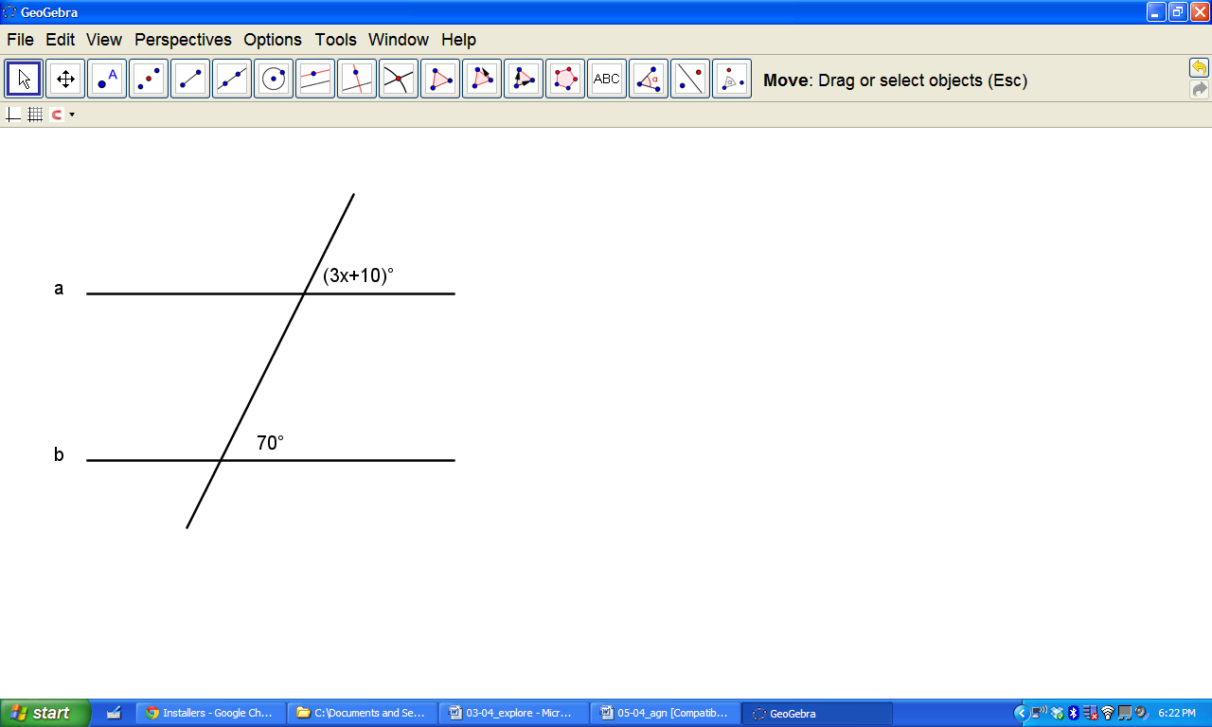

7. For lines a and b to be parallel, what is the value of x?:        
Work: