Name:

Date:

School:

Facilitator:

3.03 Transversals and Parallel Lines

**Use diagram below for problems 1-6:**

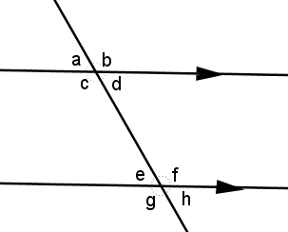Describe the relationship of the pair of angles as

* alternate interior
* alternate exterior
* corresponding
* same side interior
* same side exterior.

Then, state whether the angles are congruent or supplementary.

1. a and e: Congruent or supplementary?
2. d and e:

Congruent or supplementary?

1. b and h: Congruent or supplementary?
2. c and e: Congruent or supplementary?
3. d and h: Congruent or supplementary?
4. b and g: Congruent or supplementary?

**Find x for problems 7-11 below. Show your work for full credit.**

|  |  |
| --- | --- |
| **Description: 05-03_agn2** | **Description: 05-03_agn8** |
| **7) x =** **o** | **8) x =      o** |
|  |  |
| **Description: 05-03_agn9** | **Description: 05-03_agn10** |
| **9) x =      o** | **10) x =      o** |
|  |  |
| **Description: 05-03_agn11** |  |
| **11) x =      o** |  |

**Use diagram below to answer problems 12-18. Give your reasoning to each answer:**

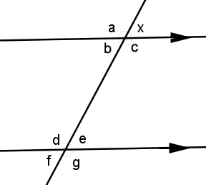**m∠x = 70o.**

12) Find m∠a: o; reason:

13) Find m∠b:  o; reason:

14) Find m∠c:  o; reason:

15) Find m∠d:  o; reason:

16) Find m∠e:  o; reason:

17) Find m∠f:  o; reason:

18) Find m∠g:  o; reason:

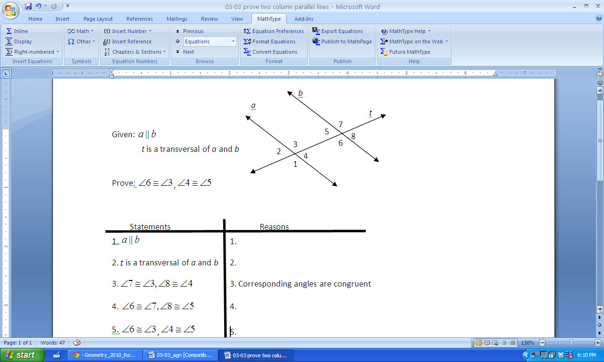**19) Match the reasons with the statement for the following proof.**

**Choices:**

**A. Transitive property of congruent angles  
 B. Given  
 C. Vertical angles are congruent  
 D. Given**

**1.       
2.       
3. Corresponding angles are congruent**

**4.**

**5.**