Name:

Date:

School:

Facilitator:

2.01 Study Guide

The calculates the slope of a line from two coordinate points from that line

The two coordinate points are listed as (x1 , y1) and (x2 , y2)

The slope formula is Description: slope_formula.gif

So if the two points are (8 , 10) and (4 , 12) … then x1 = 8 x2 = 4 y1 = 10 and y2 = 12

Now we fill in the numbers into the formula and we get 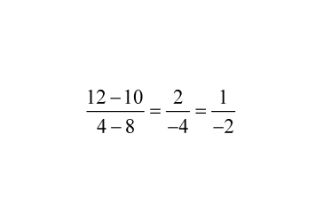

This exact same procedure can be done from a line on a graph … all that is needed is to identify two of the points from the line and then assign one as (x1 , y1) and another as (x2 , y2)

1.Linear Equation a. The amount that a line either goes up or down

2.Ratio b. y= mx + b

3.Rise c. A unique equation describing a graphable line

4.Run d. The amount that a line moves either left/right

5.Standard Form e. A comparison of two numbers often written as a fraction

6.Slope f. ax + by =c

7.Slope/Intercept Form g. A ratio describing the “steepness” of a line