Name:

Date:

School:

Facilitator:

1.06 Study Guide

**Match the term to the definition.**

Vertical Angles

Complimentary Angles

Supplementary Angles

Linear Pair

a.)Two or more angles which add up to the sum of 180°

b.) Congruent angles formed by two complete lines and sharing a common vertex

c.) Two adjacent angles which form a straight line and have a sum of 180°

d.) Two or more angles which add up to the sum of 90°

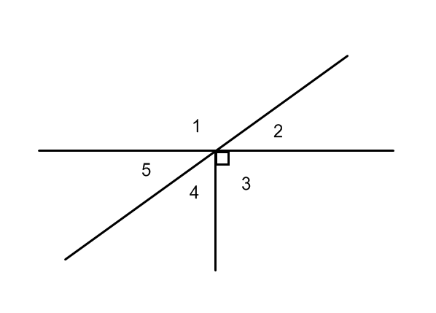

**Define the relationship between the angles as *vertical angles*, *complimentary angles*, *supplementary angles*, or a *linear pair*. If there is no relationship, write, *no relationship*. Some may have more than one answer. Supply all possible answers.**

1. ∠1 and ∠2
2. ∠5 and ∠4
3. ∠1 and ∠3
4. ∠5 and ∠2
5. ∠1 and ∠5
6. ∠2 and ∠4
7. ∠5 , ∠4 and ∠3
8. ∠4, ∠3 and ∠2

**9.** If ∠1 = 120° then what is the measure of its supplement, <2 = ?  °

**10.** If ∠5 = 50°, then what is the measure of its compliment, <4=?  °