Name:
Date:
School:
Facilitator:

1.05 Adjacent and Congruent Angles
1) What is the measure of ∠ABD in the diagram below? º
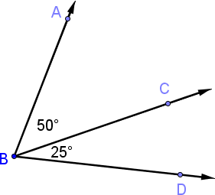

2) What is the measure of ∠WYX in the diagram below? º
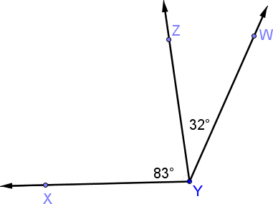

3) What is the measure of ∠MNP in the diagram below? º
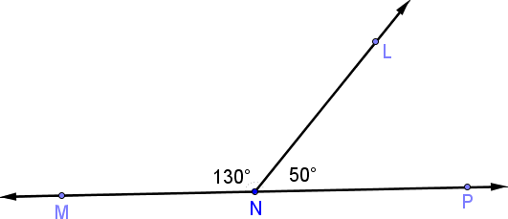

Use the diagram below to answer problems 4-6.
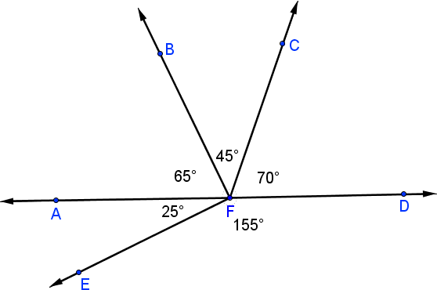

4) What is the measure of ∠BFE in the diagram above? º

5) What is the measure of ∠AFC in the diagram above? º

6) What is the measure of ∠BFD in the diagram above? º

For 7-8, Ray AB bisects angle CAD. Find the value of x.
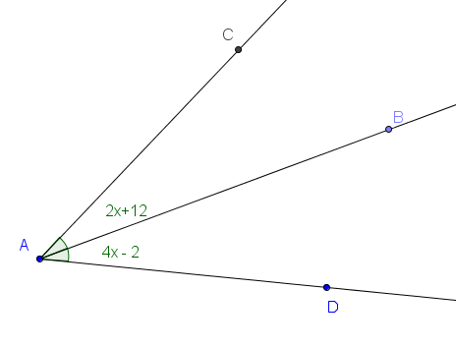
7)

Work:

Answer:

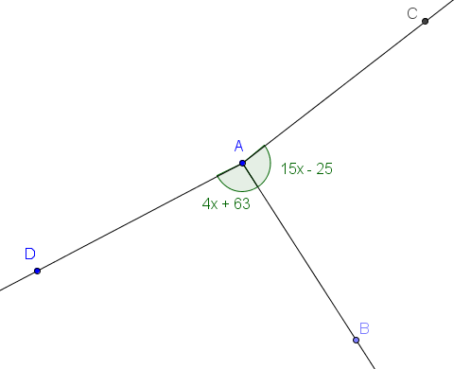

8)

Work:

Answer:

