Name:

Date:

School:

Facilitator:

1.03 Segment Partitions and Midpoint

**Given the line segment, state the ratio of the segment partitions as . Be sure to reduce fractions.**

1. 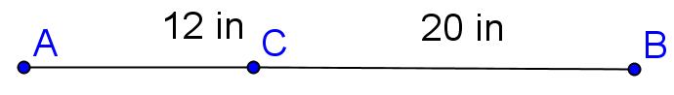

Answer:

2. 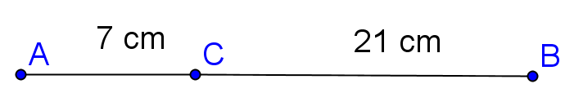

Answer:

3. 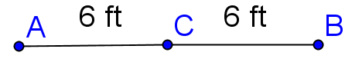

Answer:

**Given the line segment with C as the midpoint, find the length of the unknown segment.**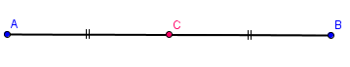

4. Given AC = 12 in 5. Given AC = 9 in

then CB =       then AB =

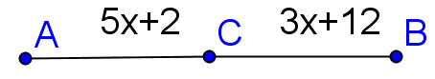  
6. Given AC = 5x + 2 and CB = 3x + 12, find x.   
Show your work.

**Initial equation:** **=**

**Answer:**

**Enter your work below.**

**Find the coordinates of the midpoint of a segment with the given endpoints. Show your work.**

7. (-3, 5), (7, -1)

**Answer:** (      ,      )

Show your work below.

8. (4, -3), (-6, 6)

**Answer:** (      ,      )

Show your work below.

.