Name:
Date:
School:
Facilitator:

1.01 Points, Lines, and Planes
Use the diagram below to answer the following questions.

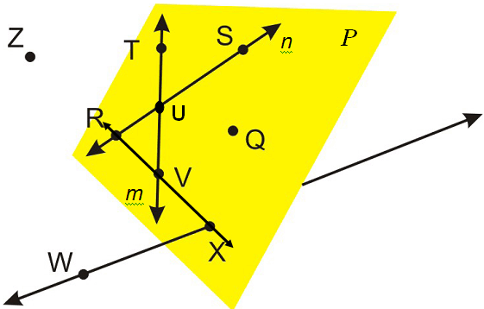

- Name three sets of collinear points.
a. , , and .
b. , , and .
c. , , and .

- Which point is the intersection of $\overset{⃡}{RS}$and $\overset{⃡}{VT}$?
- What is another name for the line m? Place the appropriate symbol over your answer (Drag the symbols into place).
- Name two points that are NOT contained in or lying in plane P. and
- Provide at least two other ways to name plane P. and
- Name two coplanar lines. Place the appropriate symbols over your answers. and
- Name a line that is not contained in plane P. Place the appropriate symbol over your answer.
- Name a ray that has U as its endpoint. Place the appropriate symbol over your answer.

- A point is named with a __________________
- Name a point that is collinear with J and L.

