Name:
Date:
School:
Facilitator:

10.02 Tangents to Circles
In the figure: $\overline{AB}$ and $\overline{AC}$ are tangent to circle S.
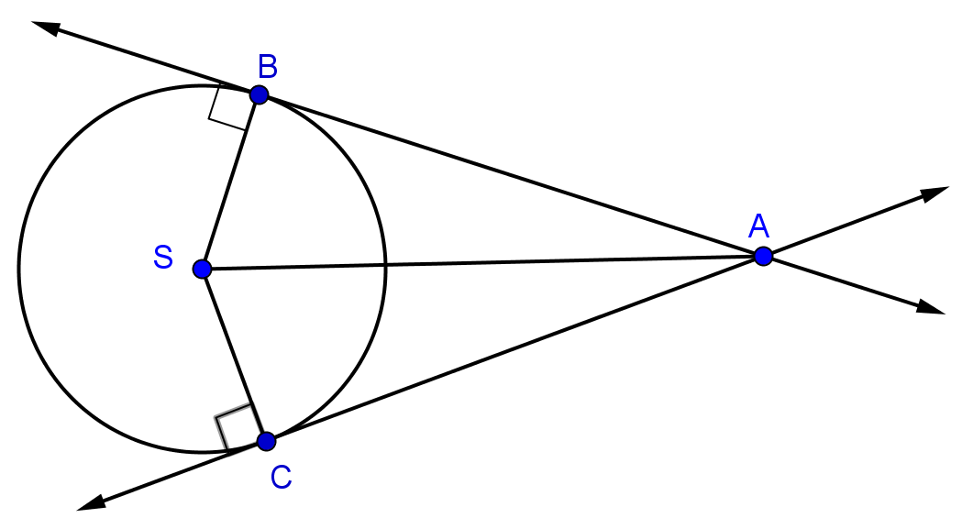

1. Find the measure of segment SB if AB = 10.5 and AS = 15 . Round to two decimal places if necessary. Show all work.

2. Find the measure of segment AS if BS = 11 and AB = 16. Round to two decimal places if necessary. Show all work.

3. Find the measure of segment AC if AS = 28 and BS = 9. Round to two decimal places if necessary. Show all work.

In the figure, $\overline{AD}$ is tangent to Circle S.

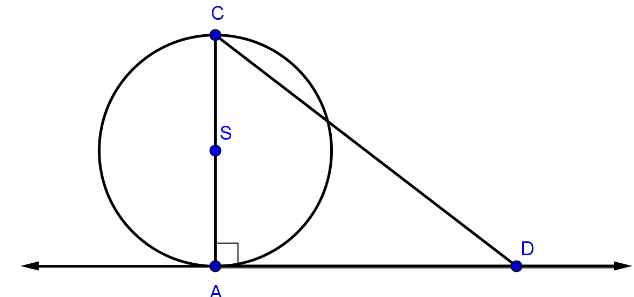

4. Find segment CD if CS = 4 and AD = 10. Round to two decimal places if necessary. Show all work.

5. Find segment AD if AS = 10 and CD = 22. Round to two decimal places if necessary. Show all work.

6. Find segment AS if CD = 26 and AD = 10. Round to two decimal places if necessary. Show all work.

