Name:

Date:

School:

Facilitator:

6.03 Dictée

Listen to the audio linked on the Task page. Try to get a general sense of what the speaker is saying. It may be necessary to listen several times. When you feel that you have the gist of what is being said, play the audio file again, this time stopping to fill in the blanks below.

When you have finished, go back to the unit vocabulary list to check your spelling of new words. Be sure that verbs are properly conjugated and that adjectives agree in number and gender with the nouns that they describe.

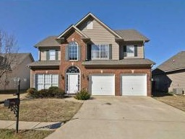

Ma maison est (1) . Elle a (2) . En haut, (3)  trois (4)  et deux (5) . (6) , il y a (7) , une cuisine, (8) , une salle de bains (9) . Mon fils (10)  et il (11) .   
Ma fille (12)  et elle (13) . Moi, je (14)  et je (15) . Nous (16)  ensemble.