Name:

Date:

School:

Facilitator:

6.01 Les Pièces

* (1.) Take a picture of a room in your house or find an Internet picture that resembles it.
* (2.) Using vocabulary that you have learned in this unit, list at least five (5) items in the room.
* (3.) Then tell (in French) three (3) daily routines that you do in the room. (This can include things like eating, sleeping, watching TV, studying, talking on the phone, reading, doing homework, surfing the Internet, listening to music, etc.)
* Use at least one (1) reflexive verb.
* (4.) Finally, tell (in French) one (1) chore that you do in this room.
* All your answers should be in complete sentences.

Example: (which you may not use)

Le salle de bains

(1.) 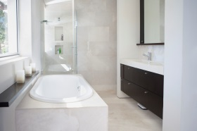

(2.) Dans ma salle de bains il y a une baignoire, un lavabo, un miroir, des serviettes, et un tapis.

(3.) Dans ma salle de bain, je me douche, je me brosse les dents et je me maquille.

(4.) Dans ma salle de bains je sors la poubelle.

(1.) Picture:

(2.)

(3.)

(4.)