Name: Date: School: Facilitator:
5.01 People and Nationality

Identify the nationality of the individuals depicted below. Use the subject provided along with the correct form of the verb ÊTRE in your sentence. Make sure that the nationality reflects the number and gender of the person or people in the image.

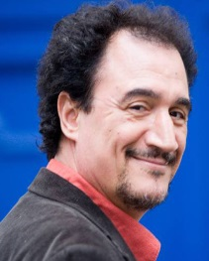  Mohamed Fellag (Algeria) | - Je | 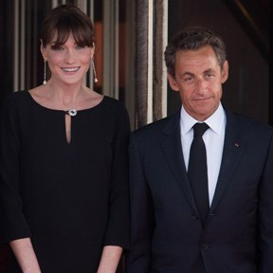  Nicolas and Carla Sarkozy  (France) | - Nous
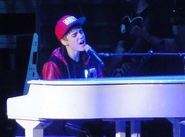  Justin Bieber (Canada) | - Tu | 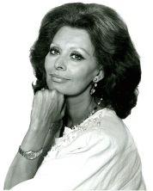  Sophia Loren (Italy) | - Vous
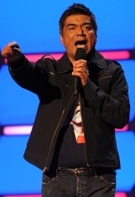  George Lopez (Mexico) | - Il | 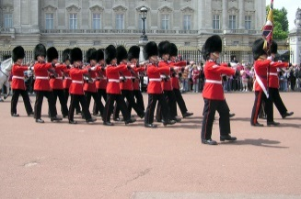  The Queen’s guards (England) | - Ils
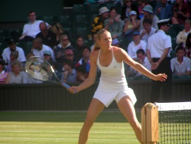  Maria Sharapova (Russia) | - Elle | 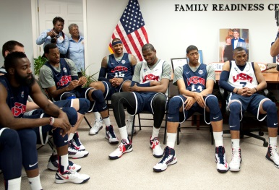  American Men’s Basketball Team | - Ils

