Name:
Date:
School:
Facilitator:

3.02 Dictation
Image | Dictation
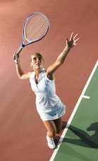 | Elle joue au tennis dans le court.
- 
- 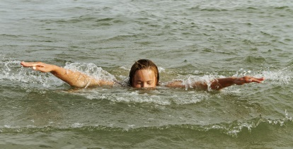
- 
- 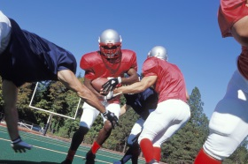
- 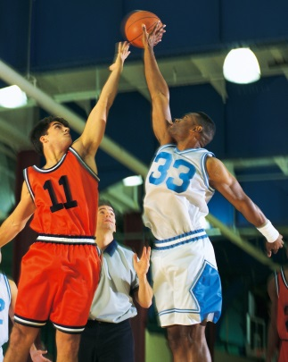
Listen to the sentences that are being read in the audio file linked on the Task page. As you listen, type each statement next to the image that matches. Accent marks count!

